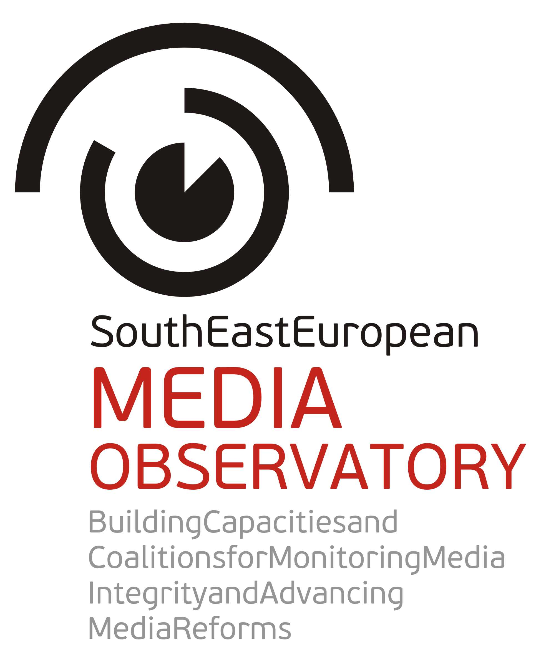 |  | South East European Media Observatory  Building Capacities and Coalitions for Monitoring Media Integrity and Advancing Media Reforms  EuropeAid/132438/C/ACT/Multi  Contract 2012/306-658
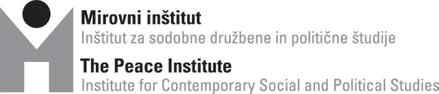 |  |  |  |  | 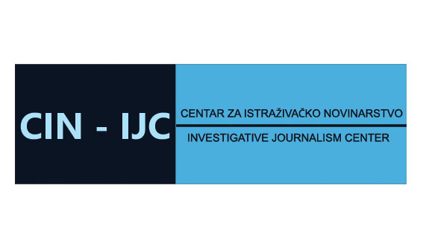
 |  |  |  |  | 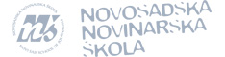
Project objective

Overall objective:
►strengthened and more dynamic civil society in the region participating in public debate on media and freedom of expression with capacity to influence policy and decision making process

Specific objective:
►greater capacity and commitment of the partner CSOs and their regional network (South East European Network for Professionalisation of the Media – SEENPM) to:
●inform and sparkle public debates on media freedom and pluralism, particularly addressing impact of media ownership and political clientelism, and
●influence media sector reform processes through developing media integrity index, regional media observatory, consultations and coalitions

►To be achieved by:
▪establishing a regional instrument – regional media observatory (as a long term project by the network) - to monitor media integrity on regular basis based on common methodology, producing highly professional national reports and regional overview, and informing reform processes on national and regional level;
▪strengthening CSOs and their regional network to influence media sector reform processes by providing them with data, additional expertise and skills, tools, institutional framework and instruments for acting;
▪building coalition among CSOs and other actors in critical assessment of the media capacity to serve democratic processes in the region, and in efforts to improve the situation;
▪providing framework for exchange of experience with successes and failures in media reforms during democratic transition and consolidation between 2 EU member states (Hungary and Slovenia) and 5 IPA countries – Albania, Bosnia and Herzegovina, Croatia, Macedonia and Serbia (with links to 3 additional IPA countries through associate CSOs – Kosovo, Montenegro and Turkey)
▪exposing decision makers on state and industry to pressure by CSOs and their network to approach the issues related to media integrity through regulation, self-regulation or other instruments;
▪informing and interconnecting media regulators and independent state bodies (anti-corruption bodies, information commissioners) as well as media self-regulatory bodies in the region;
▪empowering and engaging investigative journalists and media NGOs (journalists and citizens associations in advancing media integrity;
▪raising awareness of the general public.

Project activities

►methodology outline for monitoring media integrity (media integrity index/indicators) ▪ internal and external consultations on the strategy with stakeholders on national and regional level▪ regional workshop for researchers▪ final set up of media integrity index▪ national research and analysis of media integrity▪ sub-granting for investigative journalists▪ regional meeting of investigative journalists▪ develop tools for online presentations of media integrity index and investigative reports▪ set up regional media observatory▪ compiling media integrity national reports▪ flash reports▪ regional reports▪ recommendations▪, web and print publications▪ translation and publication in local languages▪ press conferences▪, national and regional debates/consultations with stakeholders▪ sub-granting for CSOs▪ regional workshop on advocacy▪ advocacy campaigns and public awareness on media integrity findings▪ regional meetings of independent state bodies, regulators and self-regulators▪ dissemination▪ updating media integrity index▪ project evaluation▪ expansion of the project to other IPA countries.

Results expected

►CSOs and their regional network empowered to monitor structures and practices in the media sector relevant for its role in democratic processes (media integrity) ▪ CSOs and their network strengthened to influence media sector reform processes ▪ decision makers on state and industry level exposed to pressure by CSOs to approach the issues related to media integrity through regulation, self-regulation or other instruments ▪ regulators, independent state bodies and self-regulators informed and encouraged to act ▪ investigative journalists and media NGOs engaged in advancing media integrity ▪ raised awareness of the general public.
Story  South East European  Media Observatory  ►a regional instrument to be established as a long term activity of the CSOs network to monitor media integrity on regular basis based on common methodology, producing highly professional national reports and regional overview, and informing media reform processes on national and regional level.  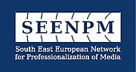 |  |  | Nurturing and fostering  prominent role of civil society in media reform processes  The regional approach  The project (strategy) implements idea that the failure of democratic transition of media systems in the region of South East Europe is demonstrated through common features. Therefore it has to be addressed on both national and regional level, applying common instruments and comparative approach, and building civil society capacities for continuing engagement and influence necessary reforms on both national and regional level.  The strategy adapts the notion of “media integrity” to capture whole set of indicators of (now dysfunctional) qualities of the media sector crucial for its ability to serve public interest and democratic processes. It puts emphasis on the political economy of the media, particularly media ownership (and its impact on media freedom) but also addresses indicators of other structural weaknesses and bad performance of media sector.  The project will establish common, systematic approach at regional level in order to tackle the issue of media integrity. In order to have an impact and wide acceptance the strategy will include a number of stakeholders; namely independent state bodies, media regulators and self regulatory bodies, media industry, investigative journalists, journalists associations, all of them being crucial players in tackling media integrity.  The project brings together CSOs from IPA countries and from two EU member neighbouring countries – Slovenia and Hungary, both with experience of media transition and ability to contribute to media reforms in the region by presenting lessons learned from successes and failures in democratic transition of media sector.  The partnership strategy builds on the results and experiences from previous regional projects of the network SEENPM aimed at critical assessment of democratic transition of media systems in the region. The strategy addresses problems identified at national and regional level and documented in recent dramatic reports (Enlargement Strategy, EC Reports, MEPs assessments, OSCE recommendations) and discussions (Speak up Conference,) on the situation with media freedom in the region.  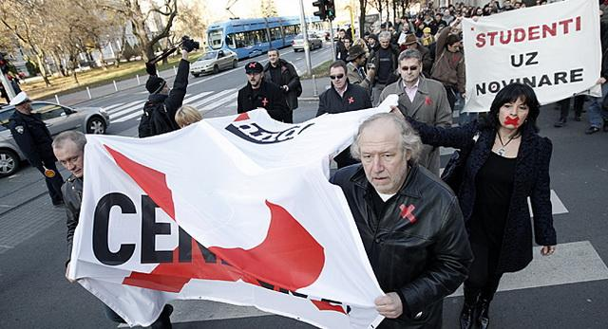  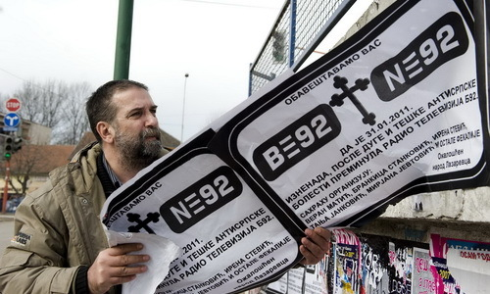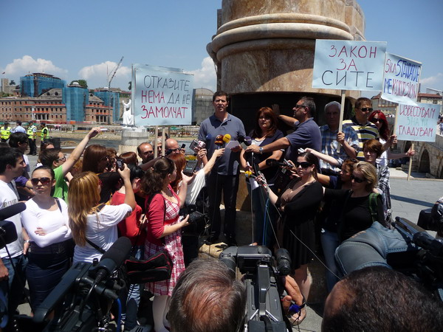  All seven civil society organizations, members of this project partnership (5 from the IPA region and 2 from EU MS) are members of the South East European Network for Professionalization of Media (SEENPM) and most of them work together for more than a decade - since the establishment of the network in 2000 - on improvements of professional standards and democratization of the media in the region of South East Europe.  SEENPM is a regional network of 18 non-for-profit media centers from 12 South East European and neighbouring countries, facilitating and supporting joint activities such as policy initiatives, research and training. Its activities are based on the belief that joint commitment and cooperation are pivotal to the development of independent media, the strengthening of relations among journalists, the stability and the overall progress of the region. The South East European Network for Professionalization of Media and its member organizations have played a unique catalyst role in transforming the formerly state controlled press into a pluralistic system and significantly contributed to the strengthening of free, independent, responsible and viable media in the region. Since its establishment in 2000 the activities of SEENPM have aimed at supporting independent, pluralistic media and addressing all major problems which undermine freedom of expression and access to information of public interest in the countries of Central and South East Europe. Since its inception in February 2000 SEENPM conducted a wide range of journalistic training, professional exchange, media policy research and advocacy projects, many of them organised by CSOs which are members of this partnership. Several thousands of media professionals have directly participated in the activities of the SEENPM network.
 | THIS PROJECT IS FUNDED BY THE EUROPEAN UNION  The views expressed in this publication do not necessarily reflect the views of the European Commission |  |  |  |  | 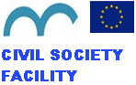
Short description of the partners
Project leader |  | Peace Institute, Institute for Contemporary Social and Political Studies (PI)  Address: Metelkova 6  1000 Ljubljana, Slovenia  Tel:+386 1 234 77 20,  Fax:+386 1 234 77 22  E-mail: info@mirovni-institut.si, brankica.petkovic@mirovni-institut.si  Web site: www.mirovni-institut.si, https://mediawatch.mirovni-institut.si  Peace Institute – Institute for Contemporary Social and Political Studies is a non-profit research institution and civil society organisation established in 1991 in Ljubljana, Slovenia. It develops interdisciplinary research and combined academic research with advocacy in various fields of public policy.  Its Media Program develops analysis of media policy and practices in Slovenia and facilitates public debates on media freedom and media development in Slovenia and Western Balkans by introducing comparative regional and international perspective. It gathers dozens media researchers and journalists from Slovenia and the region in critical studies of the media transition. It supports media reforms by contributing to development of media regulation and self-regulation, and monitoring of its implementation. It has been among founding members of the SEENPM, through which it led several regional research and advocacy projects aimed at critical assessment of media and politics, including the regional projects on media ownership and on political instrumentalisation of the media.  PI runs for more than 10 years a Media Watch program gathering dozens of journalists and academics in regular media monitoring and analysis of media practices and media policy in Slovenia and the region.  PI has participated in EU media policy studies and has also been part of initiatives for stronger involvement of the European Commission in the field of media freedom and pluralism.  Coordination of the regional project on media ownership included activities in 18 post-socialist countries, production of country reports and regional overview, regional and national books, regional and national consultations, including a regional conference in Slovenia co-organised with the Council of Europe.  PI has coordinated several EU funded projects on media and citizenship, such as Media for Citizens and RARE-Responsibility and Responsiveness in the Media. Its capacities to deliver results include regular formats of public debates organised by the PI on public policy issues, several book series including Media Watch book series with more than 25 titles published in English and Slovenian language, and Media Watch journal, as well as participation in national, regional and European expert bodies, including recent membership in the expert team supporting work of the Center for Media Freedom and Media Pluralism established recently by the European Commission within the European University Institute.  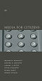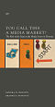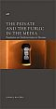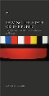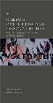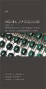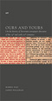  Some titles from the Media Watch book series
Partner 1 |  | Albanian Media Institute (AMI)  Address: Rr. Gjin Bue Shpata, no.8  Tirana, Albania  Tel/fax: +355 4 2229800, +355 4 2267084  E-mail: rlani@institutemedia.org  Web: www.institutemedia.org  Albanian Media Institute (AMI) is a main resource center for journalism training, media policy analysis, media research, and critical discussion on the media in Albania. It was established in 1995, providing training opportunities for more than 300 journalists per year, but also leading policy initiatives in the field of media legislation, media policy, and self-regulation. It has published more than 40 books on media and journalism, and released studies to serve public debate and policy changes in the media realm. AMI has contributed not only to improvement of professionalism of journalists, but has also implemented projects related to a more open government, in aspects of access to public institutions, strengthening of institutions’ transparency vis-à-vis the public, etc.  AMI has attempted to fulfill its mission through various activities, such as providing training courses for Albanian journalists; organizing round tables, seminars and debates on the freedom of speech, access to information, role of media in democracy; initiating research works on the Albanian media development; monitoring content and development trends of the Albanian media; supporting and initiating publications (books, manuals or magazines); providing assistance with regard to media legislation issues; and collaborating with regional and international partners in implementing joint projects. During seventeen years of its existence AMI has become the leading organization dealing with media professionalism and media role in a democratic society in the country, engaging actively in media training, policy, research, and publications.  AMI is implementing projects on media policy and media practices, including project such as “Improving professional capacities of Albanian media” and “Media policies and media professionalism in the digitalization and globalization era”.  Recently it compiled a study and organised a national debate on the role of the media in the 20 years of democratic transition of the Albanian society, as well as reports on digital media, news, and democracy and access to public institutions.. It also done a series of documentaries on freedom of expression.  AMI is one of the initiators of the SEENPM network.  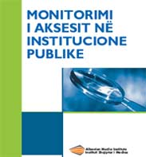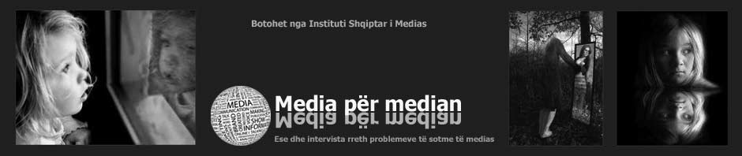
Partner 2 |  | Media and Civil Society Development Foundation “Mediacentar”  (Media Center Sarajevo, MC)  Kolodvorska 3, 71000 Sarajevo, Bosnia and Herzegovina  Phone: + 387 33 715 840  Fax: + 387 33 715 850  E-mail: kontakt@media.ba  Web: www.media.ba  Media Center Sarajevo is devoted to development of media environment in Bosnia and Herzegovina and in SEE through research, consultancy and educational projects. It was established in 1995 in Sarajevo, Bosnia and Herzegovina and since then the centre has been leader in journalism training and media research in B&H.  After the war it integrated BBC Schooll of Journalism which was attended by 229 journalists. Media Center has also implemented more than 150 other short-term and long-term training programs organized for more than 2.000 journalists and other media professionals from B&H and the region of South East Europe. Training programs covered wide variety of topics: reporting war crimes; investigative reporting; minorities and human rights in the media; enviromental journalism; to name just a few. Since 2010 all of training programs have been redefined as to accomodate new skills and knowledges imannent to digital journalism, converged newsrooms and everyday multiplatform content publishing.  Its research program is focused on media development issues in B&H and the region, many of them resulting with books which comprise country reports and regional comparative reports. Since 2005 Media Center has been monitoring media in Bosnia and Herzegovina through Media Sustainability Index (MSI), supported by IREX. Other latest research projects include: “Communication and Community: Citizens, Media and Local Governance in Bosnia and Herzegovina” (2010); “Against the Margins: Minorities and Media in SEE Europe” (2010); “Under Pressure: Research Report on Media Freedom in Bosnia and Herzegovina” (published online, 2010).  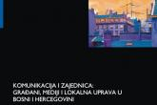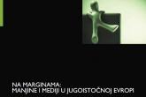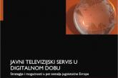  Media Center also integrates a digital archive of the B&H print media (www.infobiro.ba), and develops its web site MC Online to serve regional debate on media development (www.media.ba). Since 2011 Media Center is also a publisher of regional Roma news portal (www.tocak.org) that was supported by EC; and online resource for antidiscrimination initiatives in B&H (www.diskriminacija.ba) supported by Open Society Fund B&H.  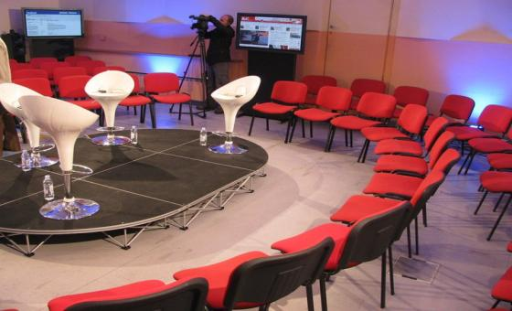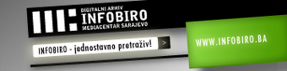
Partner 3 |  | Investigative Journalism Centre (IJC/CIN)  Address. Jure Kastelana 20, 10000 Zagreb, Croatia  Phone: +385 91 6642 224  E-mail: office@cin-ijc.com  Web site: www.cin-ijc.com  Investigative Journalism Center (IJC), established in 2003, is a non-profit association in Croatia, which aims at promoting and developing of investigative and independent journalism both in Croatia and in the region of South East Europe.  IJC/CIN engages a widespread network of trainers and media experts. It has particularly strong expertise in investigative reporting, analytical reporting, reporting on organised crime, and on political news reporting. IJC/CIN Zagreb have developed strategic partnership with similar centers in the region, e.g. with IJC/CIN Belgrade and in the period 2004-2007 with MC Sarajevo in development of series of investigative journalism courses for journalists from the region. It organised over 30 training courses, where hundreds of journalists attended, dozens of investigative stories published and several of them won journalism awards based of the IJC/CIN work.  Its projects include NetNovinar (NetJournalist), SEE media training center based on two main pillars: educational web portal for journalists and Investigative Reporting Blended Leraning Project (IRBL) „Organize crime stories“. During the IRBL Project more then 80 journalist from SEE countries have investigated and wrote stories (2004 – 2007, in cooperation with Mediacentar Sarajevo).
Partner 4 |  | Independent Journalism Foundation (CIJ)  Address: 6 Vas utca, 1088 Budapest, Hungary  Phone: +36 1 317 5448  E-mail: cij@cij.hu  Web site: www.cij.hu  The Independent Journalism Foundation (in daily work it uses the name Center for Independent Journalism, CIJ) is a foundation with a mission to promote fact-based and ethical reporting in Hungary. Since 1995 CIJ has offered professional programs to thousands of journalists, media students and managers on a non-profit basis. In recent years, CIJ held workshops on business and investigative reporting, new technologies, minorities in media, media law and ethics, the European Union, reporting trauma. CIJ regularly organizes roundtable discussions, conferences and study tours on press freedom, access to information, journalism ethics, and it cooperates with international NGOs and networks in media development. In 2007 CIJ launched the initiative for media self-regulation which led to the establishment of Editors’ Forum in 2012 in Hungary.  CIJ launched the Roma Mainstream Media Internship Program in 1998 – the first newsroom diversification project in Eastern Europe. It trained 110 students of Roma origin to become journalists. in 2009, the program was selected into the the top 30 diversity programs in the European media. CIJ currently operates a news portal (www.sosinet.hu) produced by Roma reporters.  Since 2000, CIJ has been an active member of the South East European Network for Professionalization of Media (www.seenpm.org) and has implemented joint programs in journalism training, professional exchange and media policy initiatives and also media research projects.  CIJ was part of EU-funded international projects: “Multicultural Europe in Media” - studies, workshops and the diversity toolkits for journalism trainers and CSOs in Hungarian; “Migrants in the sportlight” - media competition, a conference, internships and workshops for journalists; “Pandora’s Box” - a project to fight sexual child abuse; "Next in Line" - a journalism project bringing candidate and potential candidate countries for EU membership closer to audiences in Central Europe; "Young Roma Journalists" - project on the European Union and integration policies.
Partner 5   |  | Macedonian Institute for Media (MIM)  Address: Jurij Gagarin 17-1/1, 1000 Skopje, Macedonia  Phone: +389 2 30 90 144  Fax: +389 2 30 90 104  E-mail: mim@mim.org.mk, bb@mim.org.mk  Website: www.mim.org.mk  The Macedonian Institute for Media (MIM) is a non-profit organization that promotes excellence in media and public communication through policy initiatives, research, training, publication and production. Its main objective is to contribute to the process of democratization of Macedonia by providing assistance in professionalization of the media system in Macedonia. Since its establishment in 2001, MIM has managed around 100 small and large scale projects, also including over 100 trainings, workshops, seminars and conferences.  The Institute has published dozen of books, handbooks and manuals, as well as participated and conducted dozen of researches regarding the media sphere, such as media monitoring during elections in 2009 and 2011, as well as UNESCO Media Development Indicators report for Macedonia (2011). In 2008, MIM founded a high education institution, the School for Journalism and Public Relations that offers study programs in journalism and communications at undergraduate and graduate level.  MIM is one of key CSOs with capacity to intervene in media policy field and address violation of media freedoms in Macedonia. In 2011, it organized wide national discussions and produced a comprehensive Action Plan for improvements in the media sector and the policy framework for pluralism and freedom of media. MIM was part of the process for decriminalizing the defamation in 2006 and in 2012, but also led the Project for Support of the Implementation of the Law of Free Access to Public Information (2007 – 2009). MIM production portfolio includes the Quiz “Europe Go” aired on national TV station, a project supported by EC through “Broadcasting the EU” grant scheme 2010. One of the major projects in the area of the journalistic education was “One-Year Diploma Program in Journalism“ (2004-2008), which introduced the first specialized practical school for journalists in Macedonia.  The Institute pioneered with the media literacy in the country through the project Enhancing Media Literacy Education in Macedonia. MIM was also a partner in the Civil Society Strengthening Project whose aim was to increase citizen participation in political and social decision-making through broadening and deepening the impact of the civil society (2005-2012). In order to encourage the investigative journalism, MIM has been organizing the journalistic award for the Best Investigative Story of the Year since 2001.  The Institute has 9 full time employees and a pool of highly qualified experts, researchers and trainers with expertise in journalism, media legislation and professional ethics issues.  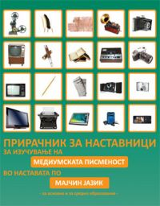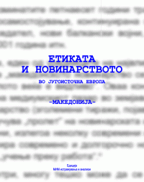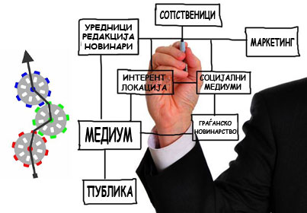
Partner 6 |  | Novi Sad School of Journalism (NNSJ)  Address: Daničićeva 3, 21000 Novi Sad, Serbia  Tel: +381 21 423 206  E-mail: office@novinarska-skola.org.rs  Website: www.novinarska-skola.org.rs  The Novi Sad School of Journalism is a non-governmental organization, founded in 1996.  By constantly improving our internationally recognized curriculum, we have become an up-to-date regional center for education and information – a resource to professions dealing with communications in the broadest sense of the word.  Our mission is to foster tolerant, well-balanced journalism that demonstrates respect for the values of truth, learning and critical approach in a multilingual, multicultural and multiethnic environment.  Our guidelines are civil society, social action, democratization European integration.  Our School works closely with the media, other educational institutions, and governmental and non-governmental organizations both at home and abroad.  We have had successful cooperation on our projects and programs with following organizations/institutions:  City of Novi Sad, Executive Council of AP Vojvodina, Ministry of Culture and Media of Republic of Serbia, Ministy for Diaspora, Council of Europe, European Commission, European Agency for Reconstruction, Fund for an Open Society, PRESS Now, Konrad Adenauer Stiftung, Norwegian People’s Aid, American Bar Association, The German Marshal Fund of US, British Council, Danish School of Journalism, Helsinki Committee for Human Rights, Ecumenical Humanitarian Organization, CeSID, European Movement for Serbia, Civil Initiatives, Gender Studies and Researches “Mileva Marić Einstein” – Novi Sad, Creative Youth of Novi Sad, Fund for Humanitarian Law, SOS “Children’s Village “Dr Milorad Pavlović, NGO New Horizon – Ulcinj, Media Plan – Sarajevo, STINA News agency – Split, Vest Foundation – Timisoara, ACCESS – Sofia and media from all over Eastern Europe and various educational institutions and organizations.  Awards: In November 2006, Novi Sad School of Journalism Student Production 3TRIP was awarded the 1st place in the category of student works and 3rd place in the category of camera at the Festival “TV nadmetanje press vitez”. The awarded feature is titled “Chocolate rapper and the white brother” – author Dalibor Stupar and director/editor Miloš Vlaški. In November 2006, the same feature was awarded the  In 1999, the Centre for Balkan Studies and Culture at the University of Graz, Austria, selected the Novi Sad School of Journalism as the only NGO from the region to receive the “Model of Best Practice” designation in the scholarly publication entitled How to Construct Civil Societies? – Education, Human Rights and Media in Southeast Europe: a Critical Guide.  8th place (out of 32) at the video competition “Dosta! : get rid of prejudices, give Roma a chance!”, supported by the Council of Europe and European Commission.
Associates  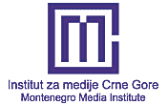  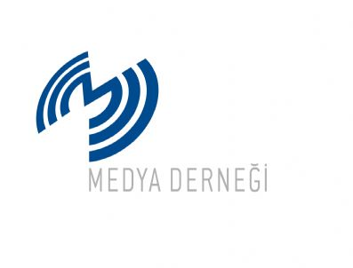   |  | Kosovo Media Institute (KMI) is a non-for-profit and non-governmental organization, envisioned as a training and media advocacy center for the media sector in Kosovo. KMI is member of the South East European Network for Professionalization of Media (SEENPM). Web site: http://imk-ks.org/.  Montenegro Media Institute (MMI) is a non-profit organisation committed to improving professional standards in Montenegrin journalism. MMI’s activities include research, publishing, production and legal initiatives for media in transition. MMI is member of the network SEENPM. Web site: http://www.mminstitute.org/.  Media Association/Medya Derneǧi Instanbul is a non-profit organization that fosters, supports and directs elevation of the standards of the media for a more democratic society in Turkey. It advocates freedom of expression and ethical values in the media. Since 2009 it has been a partner of the network SEENPM in the project with UNESCO promoting self-regulation in the media. Web site: http://www.medyadernegi.org/.  The Guardian Foundation is a non-profit entity initiated 20 years ago by Scott Trust to give practical help, training and inspiration to journalists in Eastern Europe aspiring for free and professional press. Through the work of the foundation the Guardian journalists have been lecturing and holding seminars in the countries of South East Europe for more than 15 years, most often in cooperation with CSOs, members of the network SEENPM.

