Project partners:
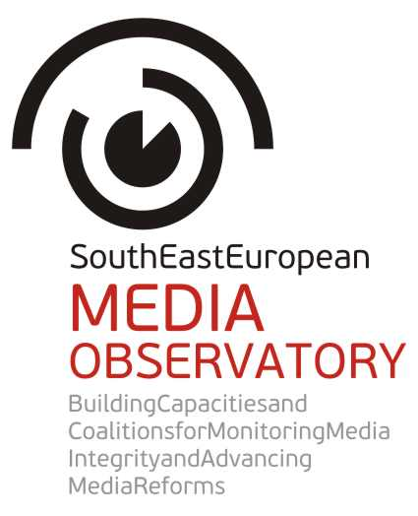 |  | 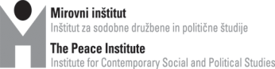
 |  | 
 |  | 
 |  | 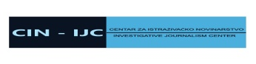
 |  | 
 |  | 
 |  | 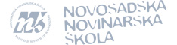

INCEPTION
REPORT
May/June 2013

Table of Content

- Project executive summary 3

- Report on the inception phase 4

- Final strategy for the implementation phase 11

- Appendixes 29
Appendix 1: Action plan
Appendix 2: Summary of the methodology outline for the media integrity research
Appendix 3: Summary of the national and regional consultations on the strategy
Appendix 4: Revised budget

Project executive summary

Title of the Action:
South East European Media Observatory:
Building Capacities and Coalitions for Monitoring Media Integrity and Advancing Media Reforms

Contract number: 2012/306-658

Duration of the Action: 1 December 2012 – 30 November 2014
Extension period: 2015 and 2016

Coordinator of the Action:
Peace Institute, Institute for Contemporary Social and Political Studies (PI)

Partners in the Action:
Albanian Media Institute (AMI)
Media and Civil Society Development Foundation “Mediacentar” (Media Center Sarajevo, MC)
Investigative Journalism Centre (IJC/CIN)
Independent Journalism Foundation (Center for Independent Journalism, CIJ)
Macedonian Institute for Media (MIM)

Novi Sad School of Journalism (NNSJ)

Associates in the Action:
Kosovo Media Institute
Montenegro Media Institute
Media Association (Medya Derneǧi), Istanbul
The Guardian Foundation

Beneficiary country of the action:
Albania, Bosnia and Herzegovina, Croatia, Macedonia and Serbia

Budget: 740.814,55 EUR, EC contribution: 592.651,64 EUR

Mission statement:
The project “South East European Media Observatory – Building Capacities and Coalitions for Monitoring Media Integrity and Advancing Media Reforms” nurtures and fosters prominent role of civil society in the media reform processes in the countries of South East Europe. In 2013 and 2014, it focuses on Albania, Bosnia and Herzegovina, Croatia, Macedonia and Serbia. The project aims at informing and sparkling public debates on media freedom and pluralism, particularly addressing the impact of media ownership and political clientelism. Its objective is to influence media sector reform processes through developing media integrity research, regional media observatory, consultations and coalitions between stakeholders.

I. Report on the inception phase

Introduction

The report on the inception phase provides overview of the activities realized between 1 December 2012 and 31 May 2013.

All activities have been realized and the objectives achieved, enabling the partnership to start the implementation phase without delays.

The project partnership benefits from the advantage of previous experience of joint work and cooperation between project partners, all of them members of the South East European Network for Professionalization of the Media, a regional network which operates since 2000.

The overall objectives of the action which have also been followed during the inception phase are: 1) empowerment of partners and our regional network for monitoring of structures and practices in the media sector relevant for its role in democratic processes (media integrity), and 2) strengthening capacities of partners and our regional network to influence media sector reform processes.

More specifically, the inception phase aimed at development of main project tools, and at the same time intended to identify and address any gaps within the Strategy by undertaking internal consultations within project management structure, and external – national and regional consultations with stakeholders. After the internal and external consultations the Strategy has been finalized and adopted by the Steering Committee in mid May 2013 and is now ready for implementation.

The inception phase included the following main activities: set up of project management structure; development of visibility tools; outline methodology for media integrity research (media integrity risk indicators); outline structure, design and editorial guidelines for the web site of the SEE Media Observatory; outline terms of references for sub-granting; internal consultations on the Strategy, including discussions about the outlined tools – through online communication and two project management meetings; external consultations on the Strategy with stakeholders on national and regional level.

Overview of activities implemented in the Inception phase
(December 2012 – May 2013)

1. Project management

1.1.Establishment of the project management and governing structure
Activity coordinator: Peace Institute

Project teams have been appointed in each partner organisation, including national project coordinators, researchers, advocacy coordinators, web coordinators and financial managers, as well as regional program coordinator, lead researcher, regional advocacy coordinator, regional web editor, regional book editor and regional financial manager. The Steering Committee members have also been appointed, consisted from directors or board presidents of each of seven partner organisations and two regional coordinators (for research and advocacy). The project team includes in total 33 members from seven partner organisations.

The Advisory Board members have been appointed based on consultations at the project kick-off meeting of the Steering Committee. It includes three members, renowned experts outside the project partnership.

The appointed Steering Committee members are: Remzi Lani (Albanian Media Institute), Ines Bamburać Alibašić (Media Center Sarajevo), Saša Leković (Investigative Journalism Center, Zagreb), Ilona Moricz (Center for Independent Journalism, Budapest), Biljana Petkovska (Macedonian Institute for Media), Dubravka Valić Nedeljković (Novi Sad School of Journalism, Novi Sad), Franja Arlič (Peace Institute), Brankica Petković (regional lead researcher and program coordinator) and Sandor Orban (regional advocacy coordinator).

The appointed Advisory Board (AB) members are: Sandra Bašić Hrvatin (Slovenia), Aidan White (UK) and Dušan Reljić (Germany and Serbia).

The names and contact information of all members of the project team are compiled in one document and made available to the whole project partnership.

1.2. Project meetings
Activity coordinator: Peace Institute

Kick off meeting of the Steering Committee on 8 and 9 January 2013 in Ljubljana: overview and initial discussion about the project strategy, overview of the job positions and tasks, overview and agreement on key project management, financial and administration issues, on visibility and communication strategy, discussion on whom to appoint to the AB.

Inception meeting of the Steering Committee and the Advisory Board on 13 May 2013 in Novi Sad: overview and evaluation of the tasks implemented in the Inception phase (first 6 months of the project);
decision on the final project design (“strategy”) – whether to keep the concept, structure and activities within the project as anticipated in the project proposal, or to change something; update on administrative and financial issues; reminder on next steps and overview of the action plan for next 6 months.

1.3 Internal communication and consultations
Activity coordinators: Peace Institute (project management, communication with the EC, research), Media Center Sarajevo (web site), Center for Independent Journalism (sub-granting), Novi Sad School of Journalism (visibility tools)

Internal communication and consultations: Online communication and consultations through e-mailing groups took place regularly on daily basis, addressing separately issues of project management and project finances, research development, web site development, sub-granting scheme development, advocacy development and visibility tools development.

Communication with the EC: Communication with the EC on daily basis was coordinated by the project leader, who simultaneously shared information and gathered feedbacks from the project partners when necessary. Communication with the EC included initial submission of info sheet on the project, information about the project activities and consultations on administrative and financial issues. It also included communication about participation of representatives of the project partnership in several EC initiated or supported meetings relevant for civil society organisations in the region engaged in media freedom issues.

1.4 Participation in the EC conferences
Activity coordinator: Peace Institute

Kick-off EC conferences, 21 January 2013 in Brussels: 6 members of the project team, representing each partner participated at the conference (the Sarajevo partner was missing because of the flight cancelation). The project strategy was initially presented at the conference by the project leader. An ad hoc meeting of the project partners was organised in one of the breaks during the conference.

Inception EC conference, 23 and 24 May in Belgrade: 7 members of the project team, representing each partner participated in the conference. The partnership presented the strategy, discussed joint issues with other partnerships, identified possibilities for cooperation, and held ad hoc meeting of the partnership. The team also made a video interview for the SEE Media Observatory web site with German Filkov, a participant, representing the partnership “Balkan Tender Watch”.

2. Research development
Activity coordinator: Peace Institute

The outline of methodology for media integrity research has been developed by the lead researcher outlining theoretical and analytical framework, including dozens of indicators for risks for media integrity. The risks are organized in four risk areas (1. media policy development and implementation; 2. media structures including media ownership, finances and public service broadcasting; 3. journalists; and 4. media practices reflected in the media content; option to include supplementary research section highlighting experiences and views of media audience with media integrity has also been considered), key research questions, methods, sources, and timetable.

The research team was consulted through online communication in two circles: one prior to the first draft of the methodology ‒ to collect ideas and suggestions, and second, after the first draft of methodology was distributed to them to collect reflections, comments and suggestions for improvements.

The research team includes: Brankica Petković (lead researcher), Ilda Londo (Albania), Sanela Hodžić (Bosnia and Herzegovina), Helena Popović and Davor Glavaš (Croatia), Snežana Trpevska (Macedonia), Jovanka Matić and Dubravka Valić Nedeljković (Serbia).

The methodology outline comprises 47 pages. Its summary was presented and discussed at the inception meeting of the Steering Committee and the Advisory Board, but also externally ‒ at five national and one regional consultations with stakeholders. It will be implemented after the research workshop which will be held in the first month after the inception phase.

For summary of the methodology outline for media integrity research see Appendix 2.

3. Web site development
Activity coordinator: Media Center Sarajevo

The strategy for the web site as an online platform of the SEE Media Observatory has been developed. Web site is one of the main instrument within the project strategy.
In the inception phase the activities within the web site strategy development included:
a) development of structure and sections of the web site;
b) web site and web pages design was developed for internal consultations within partnership;
c) editorial guidelines were outlined in details by the web editor, including action plan for contributions to be provided by each project partner during the project period;
d) web site domain has been purchased; web site will be simultaneously host by the MC Sarajevo at its own web platform “MC Online”, using the domain for its English language version. Such solution provides for the Media Observatory web site to share visitors of the MC web site, but also provides sustainability of the MO web site after the end of the project.
The web site concept, structure and design have been discussed through internal consultations within the project partnership (online consultations and at the inception meeting of the SC and AB) as well as during external national and regional consultations with stakeholders.

Discussions on the web site design and sections included considerations of some of the following solutions:
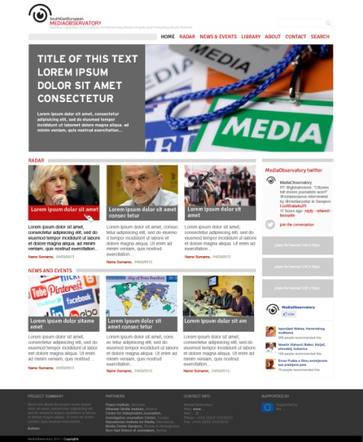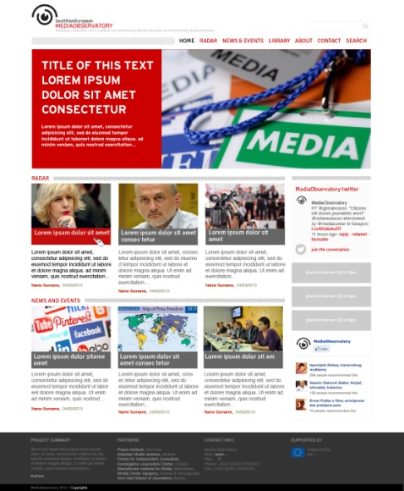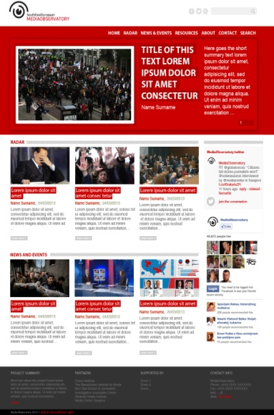

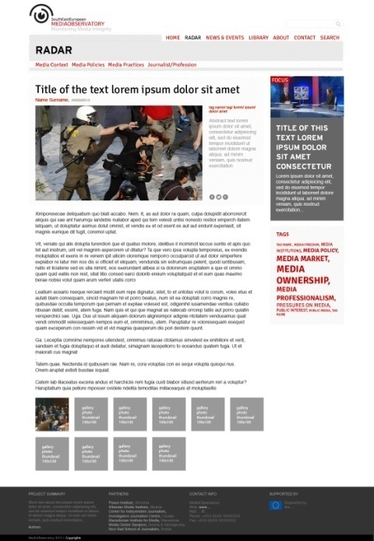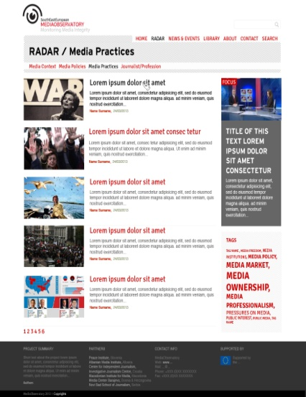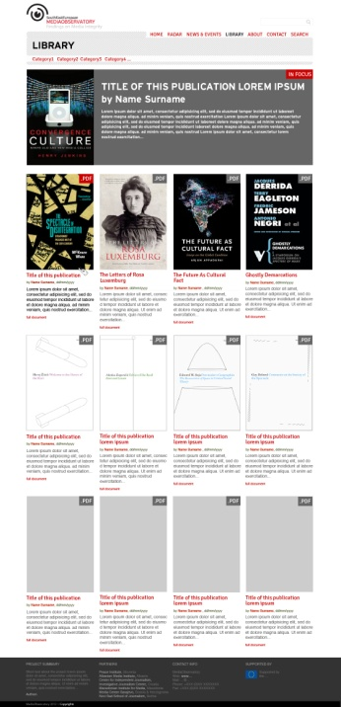

4. Sub-granting scheme development
Activity coordinator: Center for Independent Journalism, Budapest

At the kick-off meeting of the Steering Committee it was decided to launch the sub-granting scheme for investigative journalists in the first year of the action, while sub-granting scheme to media NGOs will be launched separately, at the beginning of 2014, when advocacy and public awareness activities will take place (after completion of the research).

During the inception phase the documents outlining sub-granting scheme for investigative journalists have been developed by the Center for Independent Journalism, Budapest, including Terms of References (draft call for proposals), Application Form and Contract.

The outlines for sub-granting to investigative journalists have been discussed through internal online consultations within the project partnership and at the second project management meeting – inception meeting of the Steering Committee and Advisory Board.
They were also discussed during the external national and regional consultations with stakeholders.

Action plan for sub-granting to investigative journalists was adopted as follows:
- announcement of the call for proposals 15 June, 2013
- application deadline 15 July, 2013
- meeting of the jury end of July, 2013
- announcement of the beneficiaries 15 August, 2013
- contracting sub-grantees 31 August, 2013
- publication of stories 31 December, 2013
- reports from sub-grantees 31 January, 2014

5. External consultations on the strategy:

The project idea, approach and main elements of the project strategy, including outlines of the main project tools (research, web site, sub-granting, national and regional debates, meetings and advocacy) were presented and discussed with stakeholders at regional and national level. Many constructive comments and suggestions have been elaborated by stakeholders during the consultations, all of them recognizing the importance and potential of the action and its strategy.

The consultations have been opportunity to present and discuss the strategy, but also the issues and problems with media and democracy which are addressed by the strategy.

The summary of five national and one regional consultations was compiled by the project leader and discussed at the inception meeting of the Steering Committee and Advisory Board (see the summary in the appendix of the Inception report).

5.1. National consultations
Activity coordinators: 5 partner organisations in the WB:

National consultations | Date | Number of participants
Albania | 30. 4. 2013 | 16
Bosnia and Herzegovina | 25. 4. 2013 | 12
Croatia | 17. 4. 2013 | 8
Macedonia | 25. 4. 2013 | 10
Serbia | 23. 4. and 10. 5. 2013 | 8

5.2. Regional consultations
Activity coordinator: Peace Institute

Regional consultations | Date | Number of participants
Ljubljana | 17. 4. 2013 | 6  (SEEMO, BIRN, OSCE, PSB SEE, CoE, OSF)

Total number of participants in external consultations: | 60

For summary of the national and regional consultations and lists of participants see Appendix 3.

6. Advocacy development
Activity coordinator: Center for Independent Journalism, Budapest, regional advocacy coordinator Sandor Orban

Regional advocacy coordinator Sandor Orban, who is at the same time program director of the regional network SEENPM have been initating or partipating in number of meetings with relevant regional and European stakeholders, promoting the Strategy and establishing grounds for cooperation during its impementation. It includes contacts with DG Connect of the EC, UNESCO, OSCE Representative on Freedom of the Media, IFEX, OSF Media Program etc. Such initial activities to promote the Strategy and advocate for ideas it incorporates have been realized also by program coordinator and lead researcher Brankica Petković as well as by national advocacy coordinators. For instance, coodinator in Croatia, investigative journalist Saša Leković have participated in several national events on media freedom, promoting the Strategy and its ideas. He also introduced the Strategy to the President of Croatia.

Among advocacy tools developed in this initial phase of the project, the regional advocacy coordinator has developed a calendar of national, regional, European and international events to be held in 2013 addressing media freedom and media development and as such constituting an opportunity for advocacy. The calendar will be regularly updated and used by the whole project team, especially advocacy coordinators.

7. Visibility tools development
Activity coordinator: Novi Sad School of Journalism

Visibility tools have been developed by a partner in Serbia – Novi Sad School of Journalism, starting with logo, but also including design for leaflet, folders and a banner (to be used at all project events).
The design of logo have been coordinated with the designer of the web site, and approved by the project partnership through internal consultations.

Logo of the action:

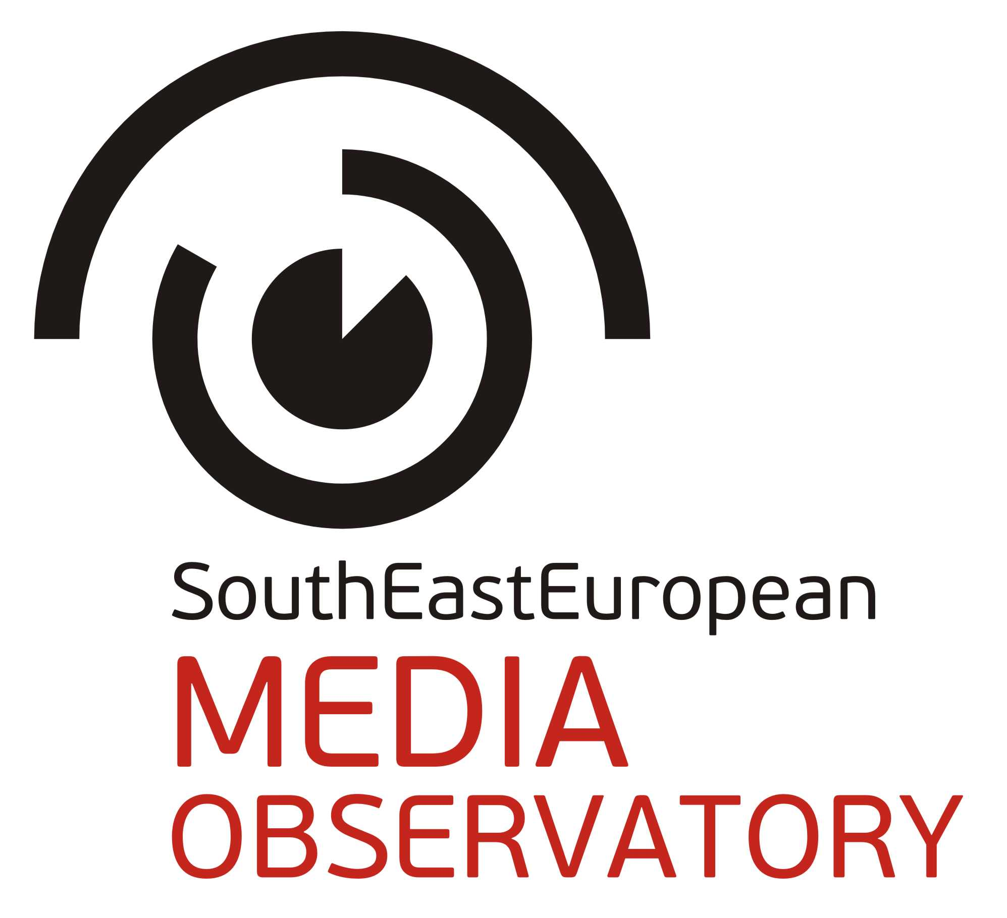

Justification of the activities in the inception phase:

Establishment of the project governing and management structure enabled the partner CSOs and their regional network to set up an internal consultation framework, communication, coordination and decision making channels for refining (and later implementation of) the strategy, for generating ideas and coordinating efforts in external consultations on national and regional level.

Inclusion of external experts in the governing structure, in supervision and in internal consultations on the Strategy provided the partner CSOs and their regional network with independent and high level expertise serving the aim of providing quality outputs.

The meetings of project governing bodies provided opportunities for structured and efficient discussion, and online consultations within the governing and management structure for continuing internal debate and exchange of ideas in the process of refining the strategy.

Outlining a methodology for monitoring and a strategy for regional web platform contributed to informing the overall strategy refining process on its two important instruments, and to establishing grounds for beginning of implementation of the Strategy immediately after the inception phase.

National and regional consultations with stakeholders was a key mechanism for providing reflection to the partner CSOs and their regional network on the Strategy from those most affected and most relevant for its implementation.

Participation in the EC conferences has enabled the project partners with feedback from the EC and other project partnerships on our strategy and expectations.

II. Final strategy for the implementation phase

Introduction

At the end of the inception phase, after internal and external consultations, the project partners have concluded to keep the main elements of the strategy, including the objectives, activities, outputs and results. However, several, rather minor and technical revisions of the strategy have been introduced.

The revisions are elaborated later in this document (See Section 10.).

The strategy aims at achieving an overall objective: strengthened and more dynamic civil society in the region participating in public debate on media and freedom of expression with capacity to influence policy and decision making process. In relation to this, by the end of the project period, the implementation of the strategy will achieve a specific objective: greater capacity and commitment of the partner CSOs and their regional network (South East European Network for Professionalization of the Media – SEENPM) to:
1) inform and sparkle public debates on media freedom and pluralism, particularly addressing impact of media ownership and political clientelism, and
2) influence media sector reform processes through developing media integrity research, regional media observatory, consultations and coalitions.
The strategy builds on the results of and experiences from previous regional projects of the network SEENPM aimed at critical assessment of democratic transition of media systems in the region.
It includes most relevant and vital national CSOs in 5 IPA countries (Albania, Bosnia and Herzegovina, Croatia, Macedonia and Serbia) and 2 neighbouring EU member states (Hungary and Slovenia) engaged in efforts for media professionalization and media policy changes in their countries. It also includes CSOs from 3 other IPA countries (Kosovo, Montenegro and Turkey) as observers (associates) in the first (implementation) period of the action, with plan to extend tools and activities to these countries in the second period (extension phase). In the part which is aimed at strengthening of investigative journalism the strategy includes a peer-to-peer support of the Guardian’s investigative and data journalists, through the Guardian Foundation, which has been for more than 10 years a supporter and partner of the applicant CSO (Peace Institute, its Media Program) and the network (SEENPM) in their efforts for media professionalization in the region.
The strategy addresses problems identified through national and regional research, monitoring and debates organized in past decade by the network SEENPM and other actors, and emphasized in recent dramatic reports and discussions on the situation with media freedom in the region (EU Enlargement Strategy, EC Progress Reports, MEPs assessments, OSCE recommendations, Speak up! Conference, international missions and alerts by IPI/SEEMO etc.)

1. Strategic priority: Regional and inclusive approach
The strategy for the SEE Media Observatory implements the idea that the failure of democratic transition of media systems in the region is demonstrated through common features. Therefore it has to be addressed on both national and regional level, applying common instruments and comparative approach, and building civil society capacities for continuing engagement and influence necessary reforms on both national and regional level.
The Observatory will establish common, systematic approach at regional level in order to tackle the issue of media integrity.
It also takes inclusive approach in order to have an impact and wide acceptance, involving in all stages of the actions number of stakeholders; namely state bodies, self regulatory bodies, media industry, investigative journalists, journalists associations, who are all crucial players in tackling media integrity. The Media Observatory will provide a framework for empowerment and exchange of experience, ideas and information among stakeholders, including them in national and regional consultations, debates at the national and regional events, but also on the Observatory’s web portal; even more, some of the stakeholders will be given financial support by the SEE Media Observatory through sub-granting scheme.
The Strategy brings together CSOs from IPA countries and from two EU member neighbouring countries – Slovenia and Hungary, both with experience of media transition and ability to contribute to media reforms in the region by presenting lessons learned from successes and failures in democratic transition of media sector.
2. Strategic priority: Nurturing and fostering prominent role of civil society in media reform process
The strategy will contribute to strengthening the capacity and efforts of our CSOs to provide analysis, advocacy and monitoring of key sector reforms at national and regional level; improving the environment for civil activism and state-civil society dialogue at regional and national level; and improving the legitimacy, transparency and accountability of CSOs in the region by:
▪empowering and equipping our CSOs and the regional network with tools to monitor structures and practices in the media sector relevant for its role in democratic processes (media integrity), particularly impact of media ownership and political clientelism on media freedom and pluralism;
▪establishing a regional instrument – regional media observatory (as a long term project by the network) – to monitor media integrity on regular basis based on common methodology, producing highly professional national reports and regional overview, and informing reform processes on national and regional level;
▪strengthening our CSOs and the regional network to influence media sector reform processes by providing them with data, additional expertise and skills, tools, institutional framework and instruments for acting;
▪building coalition among our CSOs and other actors in critical assessment of the media capacity to serve democratic processes in the region, and in efforts to improve the situation;
▪providing framework for exchange of experience with successes and failures in media reforms during democratic transition and consolidation between 2 EU member states (Hungary and Slovenia) and 5 IPA countries – Albania, Bosnia and Herzegovina, Croatia, Macedonia and Serbia (with links to 3 additional IPA countries through associate CSOs – Kosovo, Montenegro and Turkey)
▪exposing decision makers on state and industry level to pressure by our CSOs and the network to approach the issues related to media integrity through regulation, self-regulation or other instruments;
▪informing and interconnecting independent state bodies in the region, especially anti-corruption bodies, to systematically approach the issues related to the media;
▪by empowering and engaging investigative journalists and media NGOs (journalists and citizens associations in advancing media integrity;
▪raising awareness of the general public.
The partnership strategy will be implemented as to ensure regional, national and grassroots initiatives. At regional level, the network SEENPM will be strengthened through established regional observatory, which will play a major role in monitoring and advocating the media reform processes in the region (5 IPA countries, and in the extension phase to additional 3 IPA countries). At national level, the strategy will provide for media integrity research, annual and flash reports to inform and support advocacy for media reforms at national level. Through a sub-granting mechanism for investigative journalism and journalists associations it will ensure development of additional watchdog and advocacy instruments on grassroots level.
The partnership strategy will ensure the regional CSO network (SEENPM) with capacity to add value to national CSOs efforts to provide analysis, advocacy and monitoring of media ownership and media funding, media concentration, political interference, instrumentalisation and clientelism in the media sector (integrity of media sector and profession) as well as lack of independence and efficacy of media regulators, as a threat for freedom of expression, media freedom and pluralism.
The strategy will – by providing instruments and framework for dialogue and influence – empower our CSOs and the regional network to become more recognized by the Governments and other decision making institutions on national, regional and European level, and given a stronger role in the reform processes.
3. Strategic priority: Introducing and exploring the concept of media integrity
Within the methodology outline for media integrity research, developed in the inception phase, the concept of media integrity has been elaborated in details.
Media integrity encompasses qualities of the media system – policies, structures and practices in the media field, and their relations – which enable the media to serve public interest and democratic processes, demonstrating in their operations and content:
- freedom and independence from particular/special private or governmental interests,
- transparency of own operations and interests including clear disclosure of exposure to or dependence upon particular private or governmental interests,
- commitment to and respect for ethical and professional standards, and
- responsibility and responsiveness to citizens.

Media integrity more specifically refers to:
- ability of the media to provide accurate and reliable information to citizens without dependence upon, serving of and clientelistic relations with particular/special private or governmental sources, as well as to
- provide citizens with access to and expression of wide range of views and opinions without exposure to bias and propaganda.

Media integrity also integrates:
- capacities of journalists and other media professionals to apply professional autonomy and standards, demonstrating commitment to serve public interest against relations and practices which corrupt and instrumentalize the profession for particular/special private or governmental interests. Such journalistic capacities include
- transparency of dependence upon particular interests and sources and commitment of journalists to protect professional standards in such circumstances.

Media integrity relates to the notions of media freedom and independence, as well as to media pluralism, but within attempt to capture causes for and manifestations of dysfunctional democratic role of the media in South East Europe it tends to develop additional analytical category focusing on institutional corruption in the media system, on manifestations of economy of influence and conflicting dependence (Lessig 2010) in the media sector.
It is useful for our analytical framework to apply also the concept of political clientelism. According to Hallin & Papathanassopoulos (2002) and Hallin and Mancini (2004) political clientelism is “a pattern of social organisation in which access to social resources is controlled by patrons and delivered to clients in exchange for various kinds of support”. It is “contrasted with forms of citizenship in which access to resources is based on universalistic criteria and formal equality before law” (Ibid.). “While rational-legal authority tends to be associated with a political culture that enshrines the notion of the ‘common good’ or ‘public interest’, in a clientelist system commitment to particular interests is stronger”.
4. Strategic priority: Search-deliver-debate-change

By applying the concept of media integrity and the framework of the regional media observatory the action will be realized in four steps:
- Search the field of media integrity through research and investigative journalism
- Deliver the answers/findings through online and print platforms
- Debate the answers/findings with stakeholders online and at public events
- Change the field – influence media reforms through advocacy by CSO partnership, but also by sub-grantees – professional associations and other media NGOs.

Beside these key steps, the three other strategic, but rather technical components will be realized:
- Capacity building: the capacities for the search of the field and the advocacy for change will be developed through research and advocacy workshops and investigative journalism workshop.
- Visibility of the action: visibility tools and actions will be used to promote the strategy and the partnership.
- Project management: management, coordination and communication structure and tools will be used to enable realization of the action, its evaluation and administrative reporting.

4.1 Searching the field of media integrity
Activity | Activity coordinators/implementators | Time frame
Research | Regional coordination: Peace Institute  National coordination: 5 partners in Albania, BiH, Croatia, Macedonia and Serbia | Month 8-12
Sub-granting to investigative journalists | Regional coordination: Center for Independent Journalism, Budapest  National coordination: 5 partners in Albania, BiH, Croatia, Macedonia and Serbia | Month 7-13
Journalistic investigations | Sub-grantees | Month 10-12

4.1.1 Research
The media integrity – capacities and qualities of the media sector to serve public interest and democracy – will be searched through complementary effort of research end investigative journalism: own research team and investigative journalists being selected through sub-granting scheme of the SEE Media Observatory. Both efforts will be supported by capacity building workshops, the one for investigative journalists with involvement of the Guardian as an associate organisation to the partnership.
The strategy for the media integrity research incorporates a holistic approach: In order to grasp the scale of the issues covered by the concept of media integrity as a new analytical category, we suggest a holistic approach in the methodology design. The holistic approach means to explore the media systems in the region on various levels: on the level of media policy development and implementation, but also on the level of media structures and institutions, as well as on the level of media practices and contents. Within that analytical framework we put special focus on media ownership and finances, but also examine the position of journalists.
The media integrity research will be guided by the following key research questions (separately, particular research questions have been developed for each of the identified research areas)
Whether and in which way media systems in the countries of SEE integrate risks of institutional corruption and political clientelism?
How these risks influence ability of media to serve public interest and democratic role?
Particularly, how they are manifested in four areas: media policy development and implementation, media structures and institutions (specifically media ownership, finances and public service broadcasting), journalists and media practices (content)?
Which policies, structures and practices can be considered “agents of change” in terms of protection of media integrity and advancing democratic media reforms?

4.1.2 Investigative journalism
The strategy for support to investigative journalism includes announcement of a sub-granting scheme for journalists to investigate practices and cases of corruption, clientelism and abusive, excessive control of the media by particular interests in five countries in the Western Balkans and on cross-border, regional level. The investigative projects shall focus on the current situation, but can also explore cases and practices from the past if they have an impact on the present media situation. The SEE Media Observatory will provide five grants per 5.000 EUR each to investigative journalism teams in the region for their project.
Topics of local and/or regional relevance shall be related to one or more of the following or related areas: lack of transparency in media ownership; concentration of media ownership; exposure of certain ownership patterns to clientelism and corruption; role of the state in media ownership and finances; rise and fall of local, national and regional media empires in SEE; privatisation of media; corrupt practices in operating and governing public service media and regulatory bodies; lack of transparency of media finances; politically biased allocation of public resources (frequencies etc.) in the media sector; political and economic dependence of the media outlets and partisan journalism; media market irregularities; distribution of state advertising in the media; organized crime and the media; irregularities in labour relations; attacks and threats targeting journalists engaged in disclosing corruption and clientelism, etc.

4.2 Delivering the findings
Activity | Activity coordinators/implementators | Time frame
Quarterly flash reports on media integrity | Regional coordination: Sandor Orban, Center for Independent Journalism, Budapest  National coordination: 5 research coordinators in Albania, BiH, Croatia, Macedonia and Serbia | Month 7-24
Investigative journalism reports | Regional coordination: Center for Independent Journalism, Budapest  Sub-grantees – selected investigative journalism teams from Albania, BiH, Croatia, Macedonia and Serbia | Month 10-12
Research reports on media integrity | Regional coordination: Peace Institute, Ljubljana  National coordination: 5 research coordinators in Albania, BiH, Croatia, Macedonia and Serbia | Month 13-14
Web site | Regional coordination: Media center Sarajevo  National coordination: 5 web coordinators in Albania, BiH, Croatia, Macedonia and Serbia | Month 7-24
Books with research reports | Regional coordination: Peace Institute, Ljubljana  National coordination: 5 publication coordinators in Albania, BiH, Croatia, Macedonia and Serbia | Month 14-15
Press conferences | National coordination: 5 advocacy coordinators in Albania, BiH, Croatia, Macedonia and Serbia | Month 15

After searching the field of media integrity through research and investigative journalism the findings will be delivered through:
- quarterly flash reports
- investigative journalism reports (national and cross-border)
- research reports (national and regional)
- online and print publication of the findings
- press conference.

4.2.1 Flash reports
In order to rapidly respond to emerging problems and current issues related to media integrity, the SEE Media Observatory project partners will produce a series of brief analytical reports in Albania, Bosnia and Herzegovina, Croatia, Macedonia and Serbia. The production of the flash reports is supervised by the regional advocacy coordinator who works in close cooperation with the regional lead researcher.

The flash reports not exceeding 1.500 words need to be concise, thoroughly researched and contain at least two brief quotes from relevant stakeholders. The topics of the papers are to be in line with the four major media integrity risk areas identified by the project team: media policy development and implementation, media structures including ownership and public service broadcasting, media practices, and the work and situation of journalists.
The flash reports will first be published on the project website, then on the web page of the South East European Network for Professionalization of Media. The papers will be offered to relevant sites and those of the SEENPM member organization for dissemination. The documents will be used for international, regional and national advocacy at conferences, seminars and meetings tackling the functioning of media in the SEE region. Through the distribution of the reports the SEE Media Observatory project team seeks to outreach a wider audience.

4.2.2 Research reports
Research reports will be produced by the country researchers in Albania, Bosnia and Herzegovina, Croatia, Macedonia and Serbia. After elaboration of the situation on national, the regional comparative assessment will be developed, identifying common elements, but also differences and lessons learnt.
The strategy for delivery of the research findings include ”section by section” release to inform the media reform processes and the debates continuously and to keep the findings accurate at the time of delivery. Also, the complete and updated reports will be delivered at the end of the research period to include five national reports and a regional comparative overview.

4.2.3 Investigative journalism reports
Investigative journalism reports will be produced by investigative journalism teams from Albania, Bosnia and Herzegovina, Croatia, Macedonia and Serbia, selected through the sub-granting scheme. They will be published in national and international media based on the agreement between authors and the media outlets. The reports will be also published on the web site of the SEE Media Observatory.

4.2.4 Online publication
Strategy for choosing the platforms for delivery and outreach of findings (elaborated in the flash reports, investigative journalism stories and research reports) can be described as an “online-first strategy”, aiming at strong place of the web site of the SEE Media Observatory and strong activities through social networks when the findings on media integrity in the region are released.

4.2.5 Books publishing
However, platforms for delivery of the findings include also print publications: in the case of investigative journalism reports beside online also in the print media, and for the research reports – in books: national books to contain national report + regional overview in local languages; and a regional book to contain all national reports + regional overview in English.

4.2.5 Press conference
Also, the press conference will be organized in each of the WB countries included in the research and journalistic investigations – to release findings through an event aimed at providing for the media and reporters an access to summarized findings, and live statements and interpretations by the project team. For that purpose a press kit will be prepared, contributing also to the visibility of the action.

4.3 Debating the findings
Activity | Activity coordinators | Time frame
National consultations on the media integrity reports | National coordination: 5 partners in Albania, BiH, Croatia, Macedonia and Serbia | Month 16-17
Regional meeting of stakeholders – anti-corruption bodies | Regional coordination: Peace Institute, Ljubljana | Month 18
Regional final conference | Regional coordination: Albanian Media Institute | Month 20
Participation in the stakeholders’ annual meetings on national, regional and European level | Regional coordination: Sandor Orban, regional advocacy coordinator | Month 15-24
Web site – articles, blogs, comments | Regional coordination: Media center Sarajevo | Month 7-24

Debates about media integrity will include national and regional events.
4.3.1 National consultations on the media integrity findings
National consultations on the research findings will be organized to include relevant stakeholders on national level and initiate recommendations for reforms.

4.3.2 Regional meeting of stakeholders – anti-corruption bodies
Also, on regional level the research and investigative journalism findings will be debated at the regional meeting of independent state bodies (anti-corruption bodies) with the SEE Media Observatory experts to discuss possibilities for their systematic approach to the media integrity issues.

4.3.3 Participation in the stakeholders’ annual meetings
In addition to that, through participation in the annual meetings of media regulators and self-regulators, media industry associations and journalists associations on national and European level, the SEE Media Observatory experts will initiate debates on the media integrity research findings and findings of the investigative journalism team.
4.3.4 Final regional conference
Finally, the central regional conference will gather all main players on national and regional level, and within the EC, to debate the issue of media integrity, and establish regional recommendations and commitments for the media reforms.
4.3.5 Debate on the web site of the SEE Media Observatory
Debate about the research and investigative journalism findings will be organized also through the online platforms – web site of the SEE Media Observatory and social networks. The web site will initiate debate on the findings through articles written by the project team members (including prominent media experts and activists in the Advisory Board of the Observatory), but also through the comments and articles contributed by other actors and stakeholders (commissioned by the web editor).

4.4 Changing the field
Activity | Activity coordinators | Time frame
Advocacy on national level | National coordination: 5 advocacy coordinators in Albania, BiH, Croatia, Macedonia and Serbia | Month 7-24
Regional, EU and international advocacy | Regional coordination: Sandor Orban, regional advocacy coordinator | Month 18
Sub-granting to media NGOs to run advocacy campaigns | Regional coordinator of sub-granting scheme to media NGOs: Center for Independent Journalism, Budapest | Month 14-20
Advocacy by other media NGOs | Sub-grantees – media NGOs | Month 16-19

The strategy for influencing the change in the field of media integrity includes advocacy on national, regional and EU level – advocacy by the regional partnership. The task of our advocacy team is to use our findings, publications and events, and identify and use other occasions/opportunities (through the media, meetings in the parliament/government, meetings of/with the industry/journalists etc.) and ways to influence changes using knowledge generated and people gathered within the project.
The media freedom and media policy events calendar has been compiled by regional advocacy coordinator to lead the advocacy team within the partnership through the opportunities for participation and bold engagement in initiating and influencing the agenda, debates and decisions.
The calendar will be regularly updated with events on national, regional and EU level i. e. occasions for advocacy actions by the partnership.
Complementary to our efforts, advocacy and public awareness campaigns by other media CSOs – sub grantees of the SEE Media Observatory will be developed.

4.4.1 Advocacy on national level
To provide strong engagement in advocacy actions the strategy includes appointment of advocacy coordinators in each of 5 WB countries to use the material, findings and arguments produced through research, journalistic investigations and public debates, and present it at national events of other stakeholders, meetings with individual stakeholders, through letters to the state bodies, articles in the media, etc.

4.4.2 Advocacy on regional, EU and international level
Regional advocacy coordinator is appointed to coordinate and support advocacy activities of national advocacy coordinators and run own advocacy activities addressing decision and opinion makers on regional, EU and international level. A calendar of regional, European and international events on media freedom and media development in the Western Balkans will be updated to enable the regional advocacy coordinator to plan presence and interventions by him or other project team members. It includes regional and European meetings of regulators, self-regulators, etc. The budget for travel and participation in such events is provided to support advocacy engagement of regional advocacy coordinator, lead researcher and other project team members.

4.4.3 Sub-granting to media NGOs to run campaigns
Other media NGOs, primarily journalists associations in 5 WB countries will be given opportunity to receive grant from the SEE Media Observatory for their public awareness and advocacy activities on media integrity to complement the Observatory’s efforts. Five grants per 5.000 EUR each will be provided through a sub-granting scheme in 2014.

5. Capacity building
Activity | Activity coordinators | Time frame
Research workshop | Regional coordination: Peace Institute, Ljubljana  Host: Novi Sad School of Journalism, Serbia | Month 7/8
Investigative journalism regional meeting | Regional coordination:  Center for Investigative Journalism, Zagreb  Support of the associate: Guardian Foundation | Month 11/12
Advocacy workshop | Regional coordination: Sandor Orban, regional advocacy coordinator  Host: Macedonian Institute for the Media, Skopje | Month 15/16

The strategy includes capacity building actions to empower members of the regional partnership, but also sub-grantees for bold engagement in searching the field of media integrity and advocating for change.
5.1 Research workshop
Members of the research team, including country researchers appointed by partners in 5 WB countries, a lead researcher and an assistant researcher will meet to work on refining the research methodology outline, discussing the focuses in the research areas, methods and techniques. The aim of empowerment for the research task will be supported by the presence and contribution of a regional expert who is also member of the Advisory Board of the SEE Media Observatory.

5.2. Investigative journalism regional meeting
Investigative journalists selected through the sub-granting scheme of the SEE Media Observatory will meet at the regional meeting with the Guardian journalists and the host – Center for investigative journalism, a project partner in Croatia, to work on improving their skills and knowledge on the topics relevant for the investigations of the media, corruption and clientelism, and for good presentation of the findings.
5.3 Advocacy workshop
Advocacy workshop will gather advocacy coordinators from partner organisations in 5 WB countries, a regional advocacy coordinator, regional lead researcher, 5 media NGOs from Albania, BiH, Croatia, Macedonia and Serbia, selected through the sub-granting scheme of the SEE Media Observatory, and an outside expert for advocacy to develop strategy for advocacy for reforms aimed at media freedom, independence and pluralism, and media integrity in the region.

6.Visibility tools and activities
Visibility tools and actions will be used to promote the strategy and the partnership. Some of the visibility tools have been developed during the inception phase, such as logo, and design for the web site. Folders, leaflets and banners will be made at the beginning of the implementation phase, and used at the project events, but also at other occasions. For the press conference where the findings of the research and journalistic investigation will be presented to the media a press kit will be prepared, contributing to the visibility of the action.

7.Project management
Project management, coordination and communication structure and tools will be used to enable realization of the action. The project team includes 33 members in 7 partner organization, with additional 3 high level experts outside the project team participating in the Advisory Board of the project. The project coordinator – the Peace Institute – is taking a leading role in project coordination and financial administration of the action, but also partner centers have a leading role not only in their national scope of activities, but also in some regional activities assigned to them.

7.1 Project meetings
During the inception phase the partnership decided to reduce number of project management meetings during the implementation phase, and replace them with more online communication and decision making, reallocating the funds to other activities. In the implementation phase 2 project meetings will be held, but the occasions for the discussions on the project management issues will be used also during the other project events on regional level (in form of side events/meetings).

7. 2 Evaluation
An evaluator will be engaged to follow and evaluate the project implementation.
7.3. Reporting
Reporting on the project implementation will be provided by the project coordinator – the Peace Institute – with all partners contributing to the report with their segments. As a tool intended to ensure good financial management each six months internal financial reports will be compiled to provide overview of the financial developments in the project and of check of the documentation by the regional financial manager.

8. Summary of the strategy for the implementation phase
Expected results: CSOs and their regional network empowered to monitor structures and practices in the media sector relevant for its role in democratic processes (media integrity); CSOs and their network strengthened to influence media sector reform processes; decision makers on state and industry level exposed to pressure by CSOs to approach the issues related to media integrity through regulation, self-regulation or other instruments; raised awareness of the general public;

National activities: ▪National research on media integrity risk indicators; ▪Production of quarterly flash reports and (annual, detailed) national research reports on media integrity; ▪National publications with translation of country reports and regional overview in local language – publishing and distribution; ▪National consultations with stakeholders/presentation of the national report and regional overview; (part of advocacy); ▪Press conference – 30 minutes presentation of the national report and regional overview for national press + press kit to be distributed (part of communication and visibility); ▪Promotion of regional sub-granting call for applications for investigative journalists and for CSOs (journalists and citizens associations) – to be organised by partner CSO in HU; ▪Web contributions on own web site and on the Regional Observatory web site; ▪Advocacy on national level by advocacy coordinator using the material produced through research and publication – presentations within national events of other stakeholders, meetings with individual stakeholders, letters to the state bodies, articles in the media, etc., with the assistance of regional advocacy coordinator located at partner CSO in HU – Coordination of advocacy work with other national CSOs–sub-grantee(s) from respective IPA country; ▪Recruiting participants for regional events and participation in regional events;

Regional activities: ▪Set up final methodology for media integrity research and guidelines for country researchers; ▪Regional workshop for research WG; ▪Coordination of national research on media integrity; ▪Set up and launch of sub granting schemes for 1) investigative journalists (5 grants on media integrity investigations) and 2) for journalists/citizens associations (5 grants on media integrity advocacy), call for applications, selection; ▪Regional meeting of investigative journalists (sub-grantees + other investigative journalists from the region recruited by partners + 2 guests from the Guardian + regional web editor); ▪Compilation of regional flash reports on media integrity based on national flash reports (during the course of the project, and the research, also after the research, based on important events in the respective country); ▪Editing of national research reports, compiling regional overview; ▪Set up/launch of regional observatory; ▪Publishing of regional book and distribution; ▪Final set up/launch of the Observatory web site, maintenance and editing of the web site; ▪Regional workshop of advocacy WG+ sub-grantees (associations); ▪Central regional conference to present and discuss media integrity findings, and findings of investigative journalism reports; ▪ Regional meeting of stakeholders (independent state bodies – anti-corruption bodies, information commissioners etc.) with the Regional observatory (SC); ▪Investigative journalism reports published on the Observatory web site; ▪Articles and blogs published on the Observatory web site; ▪Production and distribution of promotion materials (logo of the project/Observatory, folders, pens, small notebooks) to achieve better visibility; ▪Regional advocacy and coordination of national advocacy activities; ▪Dissemination of project outcomes to the EC and other international organisations. ▪European/international advocacy – presentation of media integrity research findings and investigative journalism findings in European and international institutions/events (by lead researcher and/or regional advocacy coordinator); ▪Participation in 3rd EU meetings (month 22, whole project team: 1 applicant + 6 partners); ▪Steering Committee meetings (quarterly, 4 meetings in 24 months); ▪Advisory Board meetings – with SC (2 meetings in 24 months); ▪Communication with EC; ▪Mid-term review of the project by EC (month 18, 19, 20); ▪Evaluation of the project by independent evaluator; ▪Financial and narrative reporting to EC;

Outputs: media integrity risk indicators developed; regional media observatory established; 2 workshops for research and advocacy team organised, 1 regional meeting of investigative journalists organised; 2 sub-granting schemes set up; established and maintained web platform for regional media observatory; 5 national reports and regional overview on media integrity indicators compiled and published online and in print; 30 flash reports on media integrity produced (6 x 5 IPA countries), compiled in regional flash report (by regional advocacy coordinator) and distributed to target audiences on national, regional and European level; 5 investigative reports published; 5 national and 1 regional presentations and debates on media integrity findings with stakeholders organised; 1 regional meeting of stakeholders organised; regional meetings of project governing and supervising bodies organised; project outcomes disseminated; project outcome presented and reforms advocated at other regional, European and international events and institutions; the strategy outcomes presented and the project team informed about EC views at the final EC conference; communication with EC, including mid-term review realized; project evaluated; project reported to EC.

9. Minor revisions of the strategy for the implementation phase

The inception phase was concluded with several, but minor revisions of the Strategy.

The revisions include:
1. decrease of number of Steering Committee meetings from 8 to 4 in the 24-month project period
(reason: many issues can be addressed through online consultations, while funds for project management meetings can be better used for research, web site and advocacy);
2. decrease of number of Advisory Board meetings from 4 to 2 in the 24-month project period
(reason: many issues can be addressed through online consultations, while funds for project management meetings can be better used for research, web site and advocacy);
3. replacement of a meeting of sub-granting selection committee with online consultations
(reason: most of selection procedures for similar grant-giving schemes are done through online consultations; funds can be spared for other activities);
4. sub-granting to investigative journalists and media NGOs will not take place simultaneously, but at first the sub-granting scheme to investigative journalists will be developed in 2013 and then the sub-granting scheme to media NGOs in early 2014
(reason: it is crucial to launch sub-granting to investigative journalists in a way that journalists’ investigations are done in Year 1 simultaneously with the research, and released at the end of Year 1; both findings of the investigative journalism and scientific research will be used for debates and advocacy in Year 2 when it make sense to launch sub-granting scheme to media NGOs aimed at support to their campaigns on media integrity issues, which will be developed simultaneously with advocacy efforts of the SEE Media Observatory);
5. decrease of regional meetings of stakeholders from 2 to 1
(reason: during the consultations with stakeholders it was suggested to use the existing/regular/annual meetings of regulators, self-regulators and other stakeholders on European level and raise the issue of media integrity/initiate debates or side events there, rather than spending funds for separate events organised by SEE Media Observatory; we cut the meeting of media regulators and self-regulators which indeed have their meetings, but keep the regional meeting of anti-corruption bodies to discuss media integrity issues with the SEE Media Observatory);
6. research findings will be released section by section, and, as it was planned, complete research reports will be published after the end of the research period
(reason: to provide accuracy of data and findings on particular topics within the media integrity research at the time of publishing, and to provide regular inputs from research team to the web site and advocacy team during the research period – research findings will be released section by section; however, once it is completed, it will be updated and published in form of national report/book, as well as in a form of regional publication which will include also regional comparative overview);
7. web site editor will be provided with funds to commission articles to prominent authors, media freedom advocates outside the project team
(reason: during the consultations with stakeholders it was suggested to widen the circle of contributors to the web site in a way to include knowledgeable and reputable authors and activists outside the project partnership, providing wider spectrum of views, enriching the content of the web site and encouraging outside actors to take part in debate on media integrity in the region through SEE Media Observatory online platform).

10. Strategy for the extension phase
In year 3 and 4 of the project we plan to extend the partnership and the strategy to CSOs in Kosovo, Montenegro and Turkey. In Kosovo and Montenegro our regional network SEENPM has its members, and in Turkey a reliable long-term partner.
In the extension phase we plan to continue with media integrity research, web site, flash reports, sub-granting to investigative journalists and media NGOs, national, regional and European consultations and advocacy.
In order to sparkle debate on media integrity we also plan to add a new activity – a regional tour of media integrity debate, providing a pool of knowledgeable and articulated media professionals and media experts from the region travelling through the region and participating in the debates on media freedom and integrity of media sector together with local professionals, experts and decision makers. The debates in different cities of the region would include 3 speakers selected among stakeholders from host country and 3 from other countries in the region, including IPA countries and two neighbouring EU countries included in the project partnership.

Appendix 1:

Action plan for the implementation phase:

Year 1
 | Semester 1  (month 1-6) |  |  |  |  |  | Semester 2  (month 7-12)
Activity | 1 | 2 | 3 | 4 | 5 | 6 | 7 | 8 | 9 | 10 | 11 | 12 | Implementing body
Implementation phase
Set up final methodology/media integrity index and guidelines for country researchers |  |  |  |  |  |  | x | x |  |  |  |  | Lead CSO (PI)
Research WG workshop |  |  |  |  |  |  |  | x |  |  |  |  | Partner CSO in SRB (NNSJ)
Coordination of national research on media integrity index |  |  |  |  |  |  |  |  | x | x | x |  | Lead CSO (PI)
National research on media integrity index and compilation of national report |  |  |  |  |  |  |  |  | x | x | x | x | 5 partner CSOs from IPA countries
Set up and launch of sub granting scheme, call for appl., selection, administration of grants |  |  |  |  |  |  | x | x | x | x | x |  | Partner CSO from Hungary (CIJ)
Promotion of regional sub-granting call for applications for investigative journalists and for CSOs |  |  |  |  |  |  | x | x | x | x |  |  | 5 partner CSOs from IPA countries
Regional meeting of investigative journalists |  |  |  |  |  |  |  |  |  |  |  | x | Partner CSO from Croatia (IJC) + sub-grantees+ associate (Guardian F.)
National flash reports |  |  |  |  |  |  |  | x |  | x |  | x | 5 partner CSOs from IPA countries
Compilation and distribution of regional flash reports on media integrity based on national flash reports |  |  |  |  |  |  |  | x |  | x |  | x | Regional advocacy coordinator at CSO in HU
Set up of regional observatory |  |  |  |  |  |  | x | x |  |  |  |  | Lead CSO + 6 partner CSOs
Final set up/launch of the Observatory web site, maintenance and editing of the web site |  |  |  |  |  |  | x | x | x | x | x | x | Partner CSO in BIH (MC)
Web contributions on own web site and on the Observatory web site |  |  |  |  |  |  | x | x | x | x | x | x | All 7 partner CSOs
Articles and blogs written and published on the Observatory web site |  |  |  |  |  |  | x | x | x | x | x | x | Partner CSO in BIH (MC) + all partners and 3 IPA associates
Production and distribution of promotion materials |  |  |  |  |  |  | x | x | x | x | x | x | Partner CSO in SRB (NNSJ)
Communication with EC | x | x | x | x | x | x | x | x | x | x | x | x | Lead CSO (PI)
Financial and narrative reporting to EC at the end of inception phase |  |  |  |  |  | x | x |  |  |  |  |  | Lead CSO + 6 partner CSOs

For the following years: | Semesters |  |  |  |  |  | ip=implementation phase  ep=extension phase
Implementation phase: Semester 3-4  Extension phase: Semester 5-8 |  |  |  |  |  |  | ip=implementation phase  ep=extension phase
 | 3 | 4 | 5 | 6 | 7 | 8 | Implementing body
Editing of national research reports, compiling regional overview | x |  |  | x |  |  | Lead CSO (PI)
Publishing of regional book and distribution | x |  |  |  | x |  | Lead CSO (PI)
National publication with translation of country report and regional overview in local language | x |  |  |  | x |  | ip: 5 partner CSOs from IPA countries; ep:also 3 associate CSOs from IPA becoming partners
Maintenance and editing of the Observatory web site | x | x | x | x | x | x | Partner CSO in BIH (MC)
Web contributions on own web site and on the Observatory web site | x | x | x | x | x | x | ip: all 7 partner CSOs; ep: also 3 associate CSOs from IPA becoming partners
Investigative journalism reports written and published on the Observatory web site | x | x | x | x | x | x | ip: sub-grantees (investigative journalists) + partner CSO in BIH as host of regional web site
2nd regional call for applications for investigative journalism and CSOs within sub-granting scheme, selection, administration of grants |  |  | x |  |  |  | Partner CSO in Hungary
Promotion of 2nd regional sub-granting call for applications for investigative journalists and for CSOs |  |  | x |  |  |  | ip: all 7 partner CSOs; ep: also 3 associate CSOs from IPA becoming partners
Articles and blogs written and published on the Observatory web site | x | x | x | x | x | x | ip: all 7 partner CSOs; ep: also 3 associate CSOs from IPA becoming partners
National flash reports | x | x | x | x | x | x | ip: 5 partner CSOs in IPA; ep: also 3 associate CSOs from IPA becoming partners
Compilation and distribution of regional flash reports on media integrity based on national flash reports | x | x | x | x | x | x | ip: 5 partner CSOs in IPA + regional advocacy coordinator in CSO in HU; ep: also 3 associate CSOs from IPA becoming partners
Advocacy WG+ sub-grantees (associations) workshop | x |  |  | x |  |  | ip: 5 partner CSOs in IPA + regional advocacy coordinator in CSO in HU; ep: also 3 associate CSOs from IPA becoming partners
2nd National consultations with stakeholders - presentation of the national report and regional overview | x |  |  |  | x |  | ip: 5 partner CSOs in IPA; ep: also 3 associate CSOs from IPA becoming partners
Press conference –presentation of the national report and regional overview for national press | x |  |  |  | x |  | ip: 5 partner CSOs in IPA; ep: also 3 associate CSOs from IPA becoming partners
Advocacy on national level by advocacy coordinator and other CSOs –sub-grantees | x | x |  |  | x | x | ip: 5 partner CSOs in IPA; ep: also 3 associate CSOs from IPA becoming partners
Regional advocacy and coordination of national advocacy activities | x | x | x | x | x | x | Regional advocacy coordinator at CSO in HU
Regional meeting of stakeholders (independent state bodies) | x |  |  | x |  |  | Host: lead CSO in SLO, partic: ip: all partner CSOs; ep: also 3 associate CSOs from IPA becoming partners
Central regional conference to present media integrity findings | x |  |  |  | x |  | All partners, associates, sub-grantees, AB members, sub-contractor
Distribution of promotion materials | x | x | x | x | x | x | ip: all 7 partner CSOs; ep: also 3 associate CSOs from IPA becoming partners
European/international advocacy by regional advocacy coordinator and lead researcher | x | x | x | x | x | x | Regional advocacy coordinator at CSO in HU and lead researcher at lead CSO
European/international advocacy consultant’s assistance and advise | x | x | x | x | x | x | Sub-contractor
Upgrading and updating of the media integrity index (extension phase) |  |  | x | x | x | x | Lead CSO+all partner CSOs
Extension of the project to 3 additional IPA countries |  |  | x | x | x | x | All 7 partner CSOs; and 3 associate CSOs from IPA becoming partners
Research WG workshop (extension phase) |  |  | x |  |  |  | All 7 partner CSOs; and 3 associate CSOs from IPA becoming partners
Regional coordination of national research on media integrity index (extension phase) |  |  | x | x |  |  | Lead CSO
National research on media integrity index and compilation of national report (extension phase) |  |  | x | x |  |  | Partner CSOs in 5+3 IPA countries
Regional tour of media integrity index debate |  |  | x | x | x | x | All 7 partner CSOs; and 3 associate CSOs from IPA becoming partners
Steering Committee meetings | x | x | x | x | x | x | Lead CSO + all partner CSOs
Advisory Board meetings – with SC | x |  | x |  | x |  | Lead CSO
Participation at EC conferences |  | x |  |  |  |  | ip: All 7 partner CSOs
Communication with EC | x | x | x | x | x | x | Lead CSO
Evaluation of 24 months of the project |  | x |  |  |  |  | External expert
Mid-term review by EC (implementation phase) | x | x |  |  |  |  | Lead CSO
Financial and narrative reporting to EC |  | x |  |  |  | x | Lead CSO+partner CSOs

Appendix 2

Summary of the methodology outline
for media integrity research, developed in the inception phase:

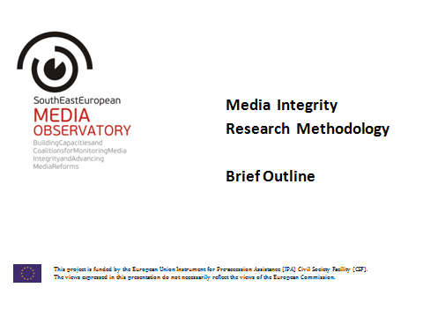

Appendix 3

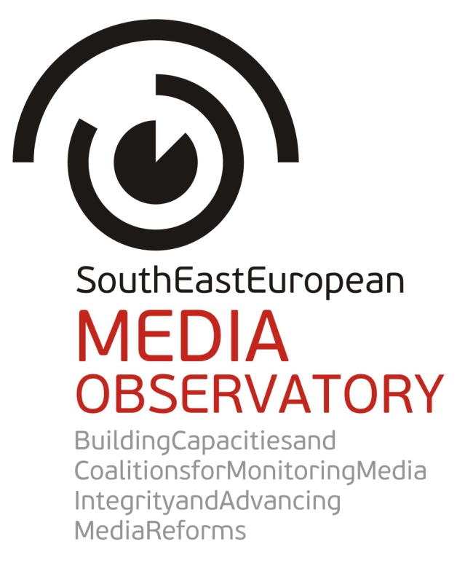

OVERVIEW OF
REGIONAL AND NATIONAL CONSULTATIONS ON THE PROJECT STRATEGY

- Participants:

Regional consultations, Ljubljana, 17.4.2013
Presenter: Brankica Petković
1 | Bojana Barlovac | BIRN, Balkan Investigative Reporting Network
2 | Lejla Dervišagić | Media Divison, Council of Europe
3 | Josip Popovac | European Association of Public Service Media in South East Europe
4 | Mark Thompson | Media Program, Open Society Foundations
5 | Oliver Vujović | South East European Media Organisation
6 | Deniz Yazici | OSCE Representative on Freedom of the Media

National consultations, Tirana, 30. 4. 2013
Presenters: Remzi Lani and Ilda Londo
1 | Sami Neza | Authority on Audiovisual Media, deputy chairman
2 | Aleksander Cipa | Union of Journalists, chairman
3 | Rrapo Zguri | University of Tirana, expert on new media, blogging, and social media
4 | Blendi Salaj | Club FM, peshkupauje.com founder, online media expert
5 | Besar Likmeta | BIRN, investigative reporter
6 | Valbona Sulce | Albanian University, specializing in new media and society
7 | Lutfi Dervishi | Editorialist, author of Code of Ethics, media expert
8 | Thanas Goga | Abacus Research, expert on media Market
9 | Alfred Lela | Mapo magazine editor-in-chief and Mapo newspaper deputy editor-in-chief
10 | Rajmonda Nelku | University of Tirana, television development expert
11 | Jonila Godole | University of Tirana, expert on media and politics, media literacy
12 | Mustafa Eric | OSCE, Media Development Unit
13 | Brunilda Bakshevani | Soros Foundation, Media and civil society programme
14 | Elira Canga | OSCE, Media Development Unit
15 | Guri Lekloti | U.S. Embassy, Public Affairs
16 | Arben Muka | Deutsche Welle, expert on radio reporting and local media

National consultations, Sarajevo, 25. 4. 2013
Presenters: Ines Bamburać and Sanela Hodžić

1 | Helena Mandić | Director for broadcasting, Communications Regulatory Agency
2 | Senad Zaimović | manager of marketing agency Fabrika, president of Managerial board of Media Industry Association (UMI)
3 | Renata Radić Dragić | Journalist, Centar for Investigative Reorting (replacement for director Lejla Bičakčić)
4 | Reuf Herić | Head of meanagers board, Association of Private RTV stations (PEM), director of Radio Q, Visoko
5 | Adi Kolašević | project specialist, TASCO
6 | Ilko Barbarić | Head of Assembly of the Association of Croatian journalists, Mostar
7 | Dragana Dardić | Executive director of Helsinki Parliament of citizens, Banjaluka
8 | Andy McGuffie | Head of communications and spokesperson of Delegation of EU to Bosnia and Herzegovina
9 | Jasna Jelišić | Policy Adviser, Delegation of EU to Bosnia and Herzegovina,
10 | Adis Šušnjar | coordinator, Association “BH journalists” (instead of Borka Rudić, secretar General)
11 | Boro Kontić | director, Mediacentar Sarajevo
12 | Izabella Kurkovski | CIM Media Expert Adviser, Press Council in B&H (written comments)

National consultations, Zagreb, 17. 4. 2013
Presenters: Saša Leković and Helena Popović
1 | Zdenko Duka | President of Croatian Journalist Association
2 | Vesna Roller | Council for Electronic Media
3 | Sanja Mikleušević-Pavić | President of Media Council
4 | Milan F. Živković | Head advisor and media adviser of the Minister of Culture
5 | Rajko Naprta | Chief of the Paper, Print and Media Department in the Croatian Chamber of Economy
6 | Jelena Berković | Deputy executive director of the GONG election-monitoring NGO
7 | Gordana Vilović | Faculty of Political Sciences – journalism professor and media analyst
8 | Danica Pribačić Jurić | project leader Independent Media Culture, NGO

National consultations, Skopje, 25. 4. 2013
Presenters: Biljana Petkovska and Snežana Trpevska

1 | Naser Selmani | President of the Association of Journalists of Macedonia
2 | Tamara Causidis | President of the Independent Union of Journalists and Media Workers
3 | Dragan Antonovski | Vice-president of the Independent Union of Journalists and Media Workers
4 | Roberto Beličanec | President of the Media Development Centar
5 | Gazmend Ajdini | Director of the Media Development Centar
6 | Mirce Adamcevski | President of the Managing Board of MIM
7 | Saso Ordanovski | Representative of the Forum of editors within AJM
8 | Metodija Janceski | Member of the Broadcasting Council of Macedonia
9 | Konstantin Jovanovski | EU Delegation in Macedonia
10 | Mihailo Lahtov | OSCE Mission to Skopje

National consultations, Novi Sad, 23. 4. and 10. 5. 2013
Presenters: Dubravka Valić Nedeljković and Jovanka Matić
1 | Kalman Kuntić | Provincial Secretariat for Culture and Public Information of AP Vojvodina
2 | Atila Marton | Deputy Managing Editor of the Public service broadcasting RT Vojvodine
3 | Samo Zjak | Director of Slovakian minority magazine Hlas Ludu
4 | Slobodan Šorak | Editor at Radio Novi Sad, public service broadcasting RTV
5 | Tatjana Novčić Matijević | Journalist and Editor at Radio Novi Sad, public service broadcasting RTV
6 | Zuzana Serenčeš | Correspondent for Radio Free Europe
7 | Nataša Krstin | Journalist on TV Vojvodina, public service broadcasting RTV
8 | Danica Todorov | Deputy Ombudsman, AP Vojvodina
Total number of participant in external consultations: 60

- Comments and suggestions by stakeholders

General
- Regional cooperation and regional exchange of experiences and information about the successes and failures in media development in the countries of South East Europe are very important.

- This is a much-needed, but also ambitious project, considering the need to have proper standards for monitoring, which would fit to all countries, as well as establish a wide consensus among stakeholders in different stages of implementation.

- Wider involvement of stakeholders as possible during the whole project is a key to the success of the project. Especially considering that “following the money” is one of the methods that would be used in research, expanding the list of stakeholders to advertising agencies and other actors that have perhaps been missing in previous studies, would be essential for the project.

- It is crucial to reach more users, including general audience, not only through MO website, but also by making sure the content is appealing enough for other websites to republish its content.

- True value of this project would be to provide for the first time, in a systematic way that surpasses individual journalistic articles an analysis of such issues that have so far been neglected or present in the public only as speculations.

- The project should produce a corpus of research findings and analyses that could provide solid arguments for the media organizations to push for substantial changes in the media sphere, but also setting a ground for opening vibrant debate.

- The expectation from the project is to make a ground for more frontal and influential debate that should be initiated by the agents of change. The project has great capacity and offers wide opportunities for the such “agents”.

- This project has potential to provide valuable data that will enable media activists to be more convincing when step out and debate in the public. It is good that the project recognizes a set of indicators that influence the media situation in the country, something for what only the journalists were blamed few years ago.

- The project provides a check-and-balances mechanism that will support media community to push for changes and incorporate the values into the system.
- The potential of the project to influence the media reforms in Macedonia is important, but also an opportunity for Macedonia to be part of such regional initiative and effort to strengthen media development in the region.

- The role of CSO in supporting journalists to continue with fighting for media integrity and their rights as journalists is very important.

Research
- When focusing on media integrity in its research dimension the Media Observatory should avoid tendency of many media research projects to excessively emphasize negative sides of media development and media functioning.

- The research should map and examine enemies of public service media in the region.

- It would be good to make some tables sheets with basic info on media landscape per country (media outlets and key players etc). This would not require much work as you are already going to need this information for your researches.

- The attempt to have an all-encompassing project in terms of research is badly needed in the Albanian context. “For years we have drafted media policies, with an absence of real data to back up the policies.”

- Lack of data on media market, newspaper circulation, audience measurement, and advertising, has turned into a real problem for the further professionalization of Albanian media. Absence of data might be a problem during the research process.

- Trend of traditional media losing slowly their role as the main source of information to new media should also be reflected in the research project. “The influence of blogs and other personalized sources of information has increased in Albania, and there is certainly a diversification of information trend going on here”. The project should reflect this trend, given that it is a long-term project.

- Some stakeholders expressed the interest to share the information during the research process.

- The research, as well as the following activities, should be more focused on several most prominent issues, rather than superficially touching the variety of issues concerning media sector.

- There are several issues that the draft methodology includes, which participants believe should be abandoned, since they are more or less considered known in BH context or they are not regarded as a significant for this project:
- there are already many sources based on media monitoring that reveal the dominant patterns of reporting on different issues and social phenomena;
- the capacities and position of journalists is also not a primary issue for a project that aims at promoting policy changes;
- political pressures such as pressures on communication regulatory agency, or pressures in the context of appointing the members of Boards of Governors in PBS media are already thematized in the public.

- Identifying positive examples of media and media practices could be useful and could enable deciphering the circumstances under which these media and practices are possible.

- Primarily to focus on the following issues:
- Advertising patterns and influence of media market
- Clientelizm
- Politization of media, as an issue even more important than the ownership structure (“Media are platforms for business, and business isn’t only about selling advertisement... now more than ever...media are becoming platforms of certain, primarily political, groups. Now every group has its own media...and this is not only in terms of political ideas, but also political reckoning”.)
- Media owned by local government, their role in representing issues of public interest, and their influence on media market through dumping of advertising revenues;
- Ownership over websites that are not registered as business, but are financed directly by political actors; while registered media are burdened by tax structure, these media are in a better position while having potentially detrimental effects on public arena;
- Ownership over the providers of the data on media use should also be addressed: more specifically ownership structure over media research agencies;
- Regulation of foreign ownership is a kind of “gray area” in BH and should be addressed too (example of Al Jazeera, bypassing regulation that specify majority of ownership over a media outlet should be domestic, by registering a company that starts up a media outlet).

- “True value of this project” would be to provide “for the first time, in a systematic way that surpasses individual journalistic articles” an analysis of such issues that have so far been neglected or present in the public only as speculations.

- Access to data on ownership structures: access to the information from the court registries is not free, and that should be considered when planning the field research. The issue whether such information on ownership could be more easily available and whether this can be regulated in some way should be addressed too.

- State aid: address the issue of public funds for media, especially in the light of the new BH Law on State Aid. It would be valuable to compare the practices in all the countries involved in the research and to identify the best ones.

- The project should address:
- non-transparency of the ownership structure which enables media owners to operate and influence the media in ways that are bypassing the laws and regulations, control and censor the journalists according to their own interests, also controlling the advertising sales and income, thus having more influence than is allowed by laws and regulations;
- weak regulation;
- powerless and non-efficient regulators (market regulators etc.)

- Researchers should engage in making contemporary frame in order to address the changing concepts of public, privacy, markets and advertising.

- Priority should be given to the following issues:
- media ownership and political influence, including also minority media,
- private-public partnerships and different models of funding at national and local level;
- lack of professional media resources;
- effectiveness of self-regulatory mechanisms and lack of knowledge about journalistic ethics.
- More systematic and longer-term media research is needed as well as new research methods and techniques, and independent research consortium which should not only come from the field of university and research institutes, but also from non-governmental organizations.

Advocacy
- For advocacy on EU level it is emphasized that the knowledge and capacities built through this project could be a valuable contribution for strengthening capacities of EU to develop policies and mechanisms to address major difficulties concerning media in pre-accession countries, to avoid potential problems as the one concerning media policies in Hungary.
Due to such experiences, state in the media sector has become an aspect that will be more evaluated in the pre-accession process.
- Still, the focus should be on national advocacy and on strengthening the advocacy capacities within the country: perhaps in our countries we have one or two organisations or maybe three NGOs in a country that the public can count on to advocate for good media practices, and that is really scarce.
We do not lack instructions from Brussels about what should be done here. What we are missing is the pressure from the public.
- It will be the best to have the final consultations on the advocacy structure after the research results are gathered, to identify priorities for future involvements.

Regional meetings
- SEE Media Observatory should organize its regional meetings and discussions around concrete media policy issues and bring together not only media policy makers from the governments in the accession countries, and other stakeholders on national and regional level, but also representatives of the European Commission to be part of the process, providing in that way that leverage of the EC is used on regional level to advance media reforms which strengthen public service requirements in the national media systems.

- In order to achieve the intended within existing capacities, the results would be best if you invest a lot in the website you are planning to launch instead of some already planned consultations and conferences.

- Activities such as meeting of regulators are not as valuable to the success of the project, since they can and will already be familiarised with the developments and the results of the project.
A representative of a regulator confirms that meetings of regulators are taking place quite often.

- Save some funding for the website and the research by cutting down such meetings and instead presenting the issues on meetings that are already being organised by third parties.

Sub-granting

- The selection process with the panel, which consists of external persons, is complicating and expensive so you can do it with your own teams in each country.
- Please keep in mind that you will also need budget for English-language editors for the commissioned stories, which is not always easy or inexpensive to find.

- It may be better if you come up with few precise topics for investigations in each country (with what exactly you want to be achieved) and just make a call for proposals rather than letting the team of journalists do on its own as you may miss the goal.

- When expecting investigations on media ownership do not focus only on “revealing” the real owners but their connection to political or economic elites. As knowing that. For instance, the fact that Zeljko Mitrovic is the owner of TV Pink does not mean much alone without the entire context, his ties with politics etc.

- The selection criteria should be based on previous journalistic record as well as on the draft plan on how the journalists intend to carry out the research, develop the idea, who to contact etc.

- Shorten the application and selection process and put it in a month only (two weeks for them to apply and two weeks for judges to decide on teams). This way you would save a month so they can have one month more for the investigation as a three-month time is not always enough, depending on how the process of collecting the data and accuracy of state bodies in their respective countries but also use of FOIA requests. This way you would have time to publish them in December 2013.

- Key point for investigative stories on media integrity to be spread and have some impact is to translate them into local languages and distribute them free of charge to all national media.

Web site and internet

- More diversified efforts than usually have to be made to provide public outreach of the research findings, not only by merely publishing and presenting them. Especially, communities on the internet and on social networks have to be mobilized through the actions of the Media Observatory aimed at initiating and generating online discussions about media integrity issues.

- In order to achieve the intended within existing capacities the results would be best if you invest a lot in the website you are planning to launch instead of some already planned consultations and conferences.

- Website should represent main hub for all your activities.

- Web site should be the place where you would be publishing all your work, findings…, but also “flash reports” or alerts on media-related issues across the region (by getting input from your relevant partner organization in that country) whenever something happens that hinders media freedom or something.

- This would all keep the website live on daily basis but also make it become the focal point for all the media practitioners to come visit it so they can get used to find there all the relevant information related to media issues.

- It would be also good make some tables sheets with basic info on media landscape per country (media outlets and key players etc). This would not require much work as you are already going to need this information for your researches.

- Promote the website with such content extensively to gain wider visibility and reach as much audience as possible.
This includes your banner on the website of all partner organizations; establishing partnership with other media centers, journalists’ associations and organizations or unions in those countries (so they would, as already established institutions, also promote your website and content thru their network and channels).

- Engage in social networks (creating a hashtag #mediaintegrity on Twitter and Facebook fan page) aimed to lure more visitors but also use it as tools to launch online debates on media-related topics.
These debates do not necessarily have to be on the topic you are working at the time but you can come up with something similar, or to use it to pulse the audience and hear how they perceive certain issues.

- With such live website with proper content and not only promotional info, the name of Media Observatory could soon become one of the key players (as there are only few regional media organizations) and a hub for media issues in the region while your newly-developed term “media integrity” could soon become a buzz word.

- It would be of huge importance to put a Twitter feed with the above-mentioned hashtag so you can have regional discussion in all languages in one place on your website.
- The reach of the website will be limited due to language barriers since the official language of the website will be English.
Many potential users will be additionally discouraged to comment in language other than Bosnian/Croatian/Serbian. Content should be promoted in local languages as well, whenever possible.
- Web site should be made the main platform for communication with the public, and she therefore suggests reallocating some funds to assure quality audience reach: “Maybe another kind of budgeting should be considered...to have...someone who can produce articles that are attractive for the readers. Partner organisations can write phenomenal reports, but these are reports for donors and won’t necessarily be readable”.

- Concern is that the audience will be saturated with reading the articles produced by the same authors, coming from partner organisations. The dynamic content, such as interviews, video interviews, statements with established authors and actors in media sector is therefore welcomed.

- Best way to engage the wider community is to enable and foster discussions on current issues concerning media integrity.

- There are doubts about the level of willingness of external contributors to produce content for the website on the volunteer basis.

- Provide constant proofreading of the produced website content.
Language issue

- Consider possibility to translate, post and promote not only reports but all content and debates of the Media Observatory in local languages, reaching out local media communities and general public.

- It would be of huge importance to put a Twitter feed with the above-mentioned hashtag so you can have regional discussion in all languages in one place on your website.

- The reach of the website will be limited due to language barriers since the official language of the website will be English.
Similarly, they feel that many potential users will be additionally discouraged to comment in language other than Bosnian/Croatian/Serbian. The participants agreed that content should be promoted in local languages as well, whenever possible

Relevant actions and sources of stakeholders:
In BH: CRA, Press Council and Council of Europe have started an initiative for developing legislation on concentration of ownership, which is now missing.

Council of Europe: CoE has a project “Promoting professionalism and tolerance in the media in Bosnia and Herzegovina”. In the framework of above-mentioned project, a Media monitoring in the period August – December 2012 was done, focusing on the hate speech in general and more specifically during the pre-election campaign (the report is attached). CoE representative said the findings could be very useful for our research. If CoE does some similar report in other countries, they will keep us informed. It is possible that Albania they will have something similar, considering the coming elections. The Council of Europe mechanism ECRI (European Commission against Racism and Intolerance) has also very detailed reports on some issues of our project interest.
CoE will probably have a regional project on media professionalism in South-Eastern Europe (Albania, Bosnia and Herzegovina, Kosovo, Macedonia, Montenegro and Serbia). Will keep us informed about this. CoE indicators for media in a democracy: BH and Serbia published the reports.

Appendix 4

Revised budget – will be submitted by 15 June 2013

